SCNSCN

SCN 064238620



|  |  |
| --- | --- |
| Alford  Academy | AARC Web and Database Information Management System |

***By Jack Watt***

|  |
| --- |
| | Watt House |

Contents

Project Proposal 3

Users 3

Project Contents 3

Analysis 4

User Survey 4

User Response Analysis 11

End User Requirements 12

System Research 12

Feasibility study 14

Legal 14

Technical 14

Economical 16

Schedule 16

Project Plan 17

Task Management 17

Deadlines 17

Schedule 17

Resource Management 17

Barriers and Alternatives 18

Specification 19

Test Plan 22

Interface Design 24

Program and Data Structures 31

Website Navigation Structure 31

System data flow diagrams 32

Web to PHP data flow 32

PHP to MySQL data flow 33

Data Structures 34

SQL Data Dictionary ResourceT 34

SQL Data Dictionary InventoryT 34

SQL Data Dictionary CheckerT 35

SQL Data Dictionary UserT 35

PHP Data Processes 36

Implementation 39

Access & SQL Tests: 39

Implementation Error Change Log; 41

Appendix: 44

Alpha Testing and Debugging 75

Test Table and Results 75

Beta Testing and Debugging 82

Amends 87

Final user Evaluation 88

Summary 88

Evaluation and Development Path 89

Evaluation of the Project Solution 89

Evaluation of the Development Process 90

Release Notes: 90

References 91

# Project Proposal

The Project in mind is a small local area network web service managed by a server machine. Its purpose is to serve up and distribute data to the connected machines, accessing the required data via an internet portal created to provide the functionality the users require.

The web service would provide data and enquiry mechanisms to the members of the Alford Academy Robotics and Code Club. This would enable them to query a server-based database and website showing club inventory or resources such as animations, diagrams on how the network was built as well as documentation on how to maintain the web service and software/files.

The Project should also have a purpose-built reporting and feedback feature.

## Users

The robotics and code club at Alford Academy require places within the school to work, using software not available on the school systems and the capability to perform certain actions without the current level of restrictions imposed by the school network.

The first identified need of the user group is that the club has multiple members and one machine needs to be able to access members’ data that may have been created on different machines.

The second initial identified requirement is the need to search the robotics inventory, especially if new kit is planned on being ordered which may already in storage. This brings the need for queries and the ability to amend the database.

A third initial requirement for the project is the documentation and resources used to create this network, along with the necessary instructions which will allow new members to become familiar with the project, learn how to set up their own basic network and maintain the existing one available to them.

## Project Contents

The Project makes use of a database hosted on a server with which I am familiar.

On the server side there will be queries, file handling and dynamic updates using appropriate data structures, accessed by clients using the web portal. For each client, the Website must have a simple, but user-friendly, feel that must contains forms and search boxes as well as a clear hierarchy for navigation so that the users may access the right data quickly and efficiently. Backing the Website is the relational database which makes data accessible, manageable and also maintains integrity throughout the processes of accessing and updating a club inventory.

# Analysis

The AARC Web and Database Information Management System will main and primary users are the Robotics club with the occasional exception of school staff or guests.

The Web based survey below shows the results from the end user group and several case exceptions in repose to an extensive set of questions relating specifically to the project without too much detail to determine suitability and feasibility.

## User Survey

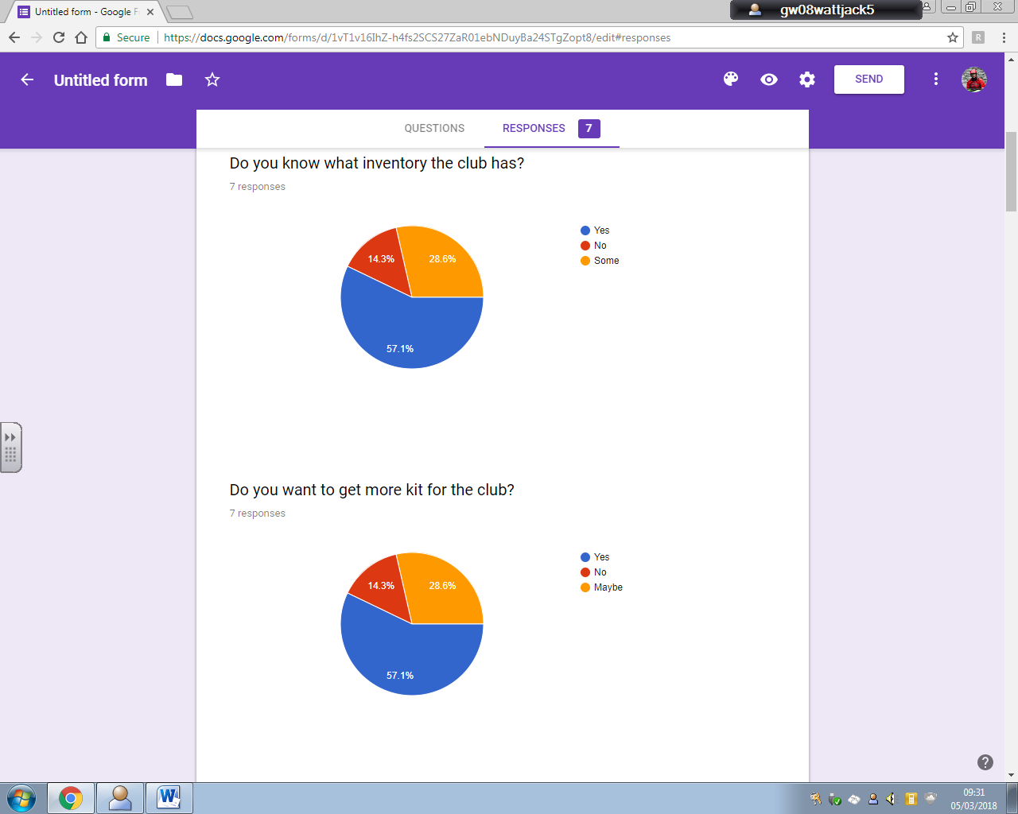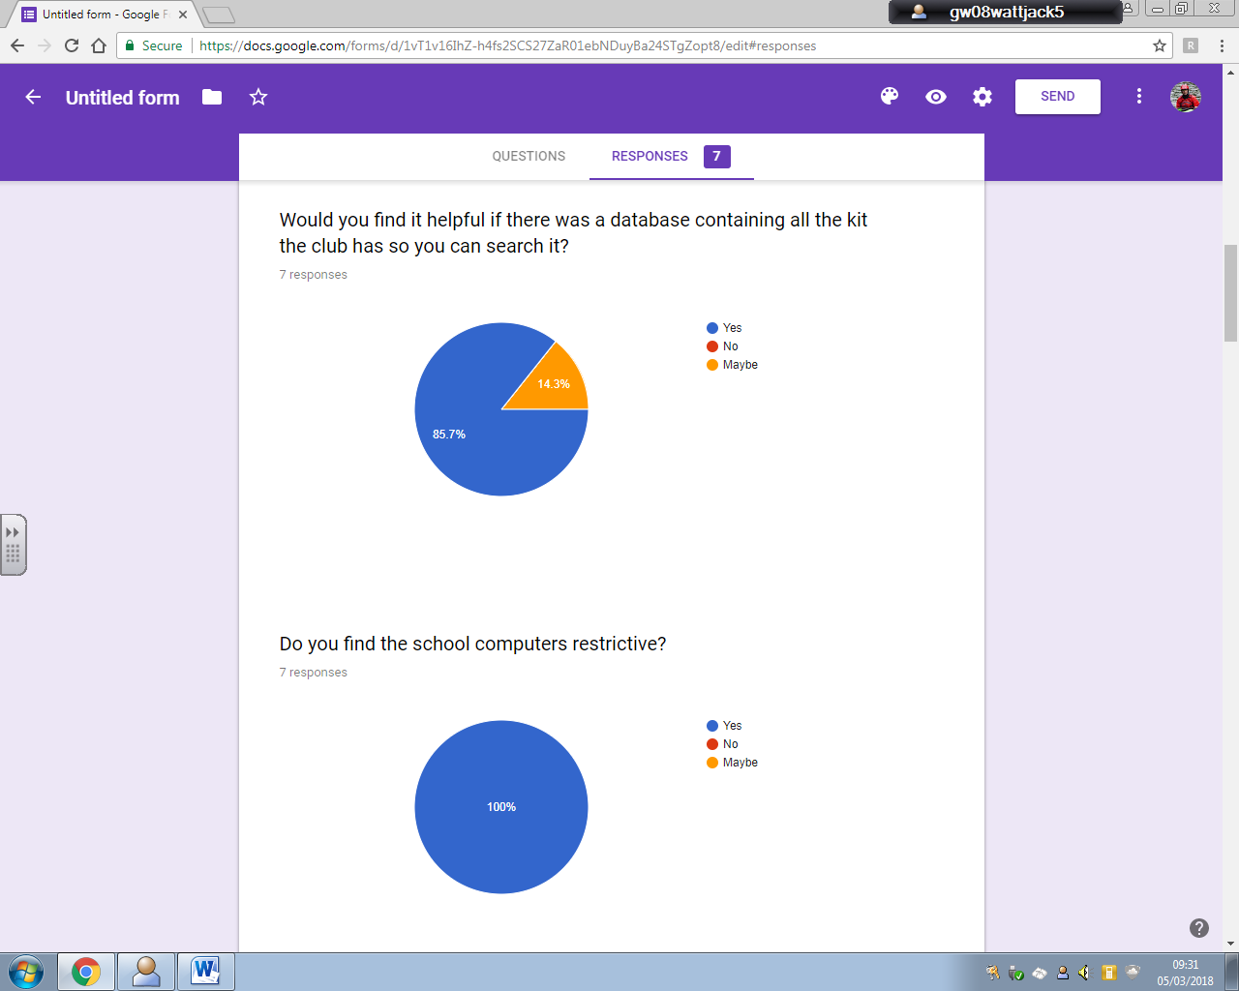



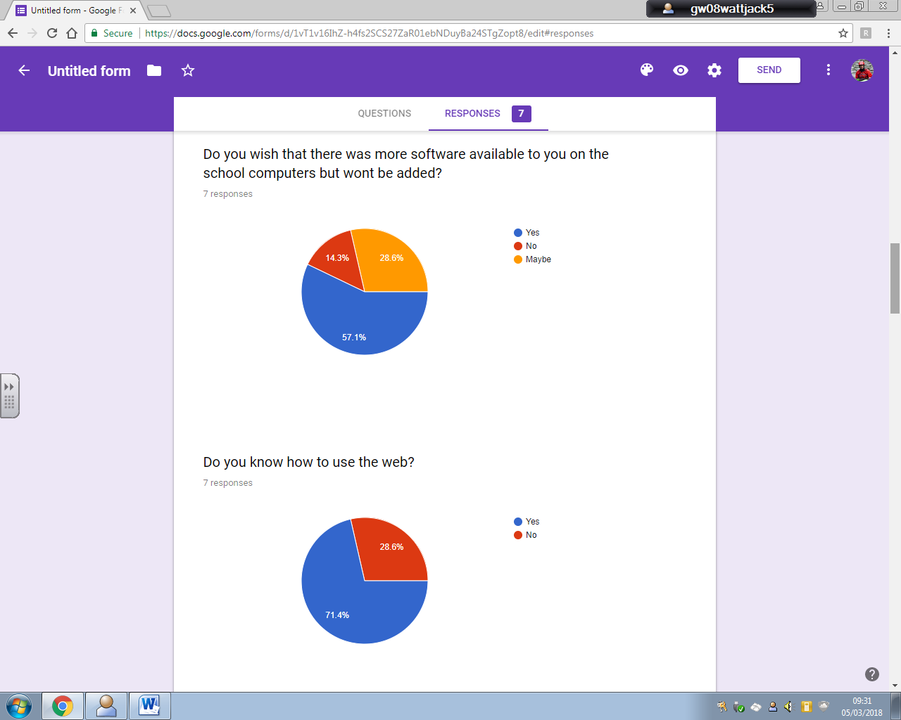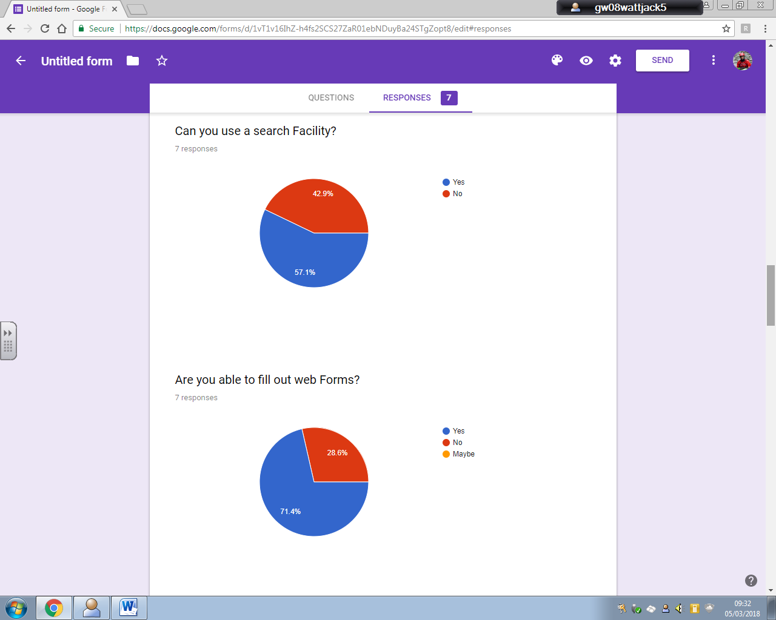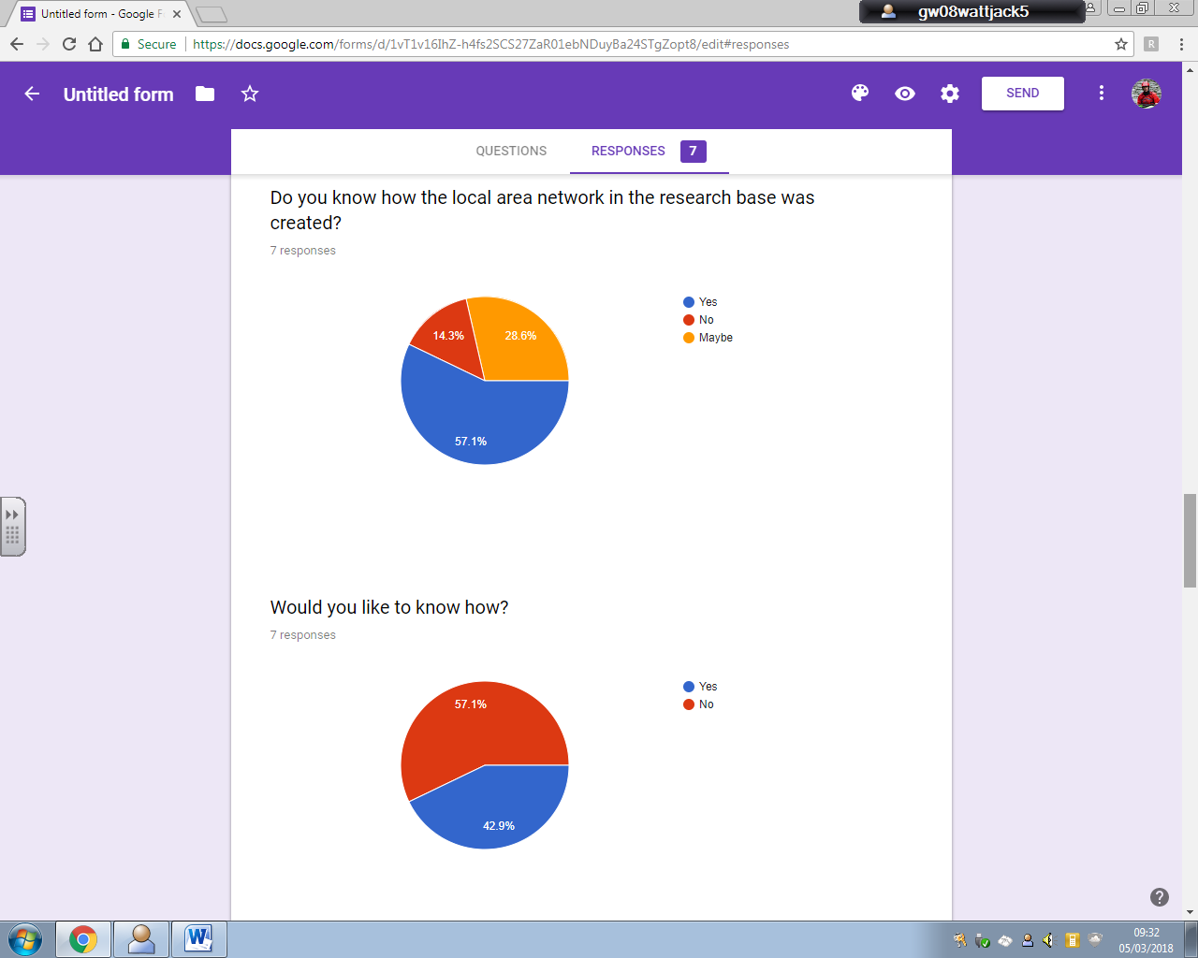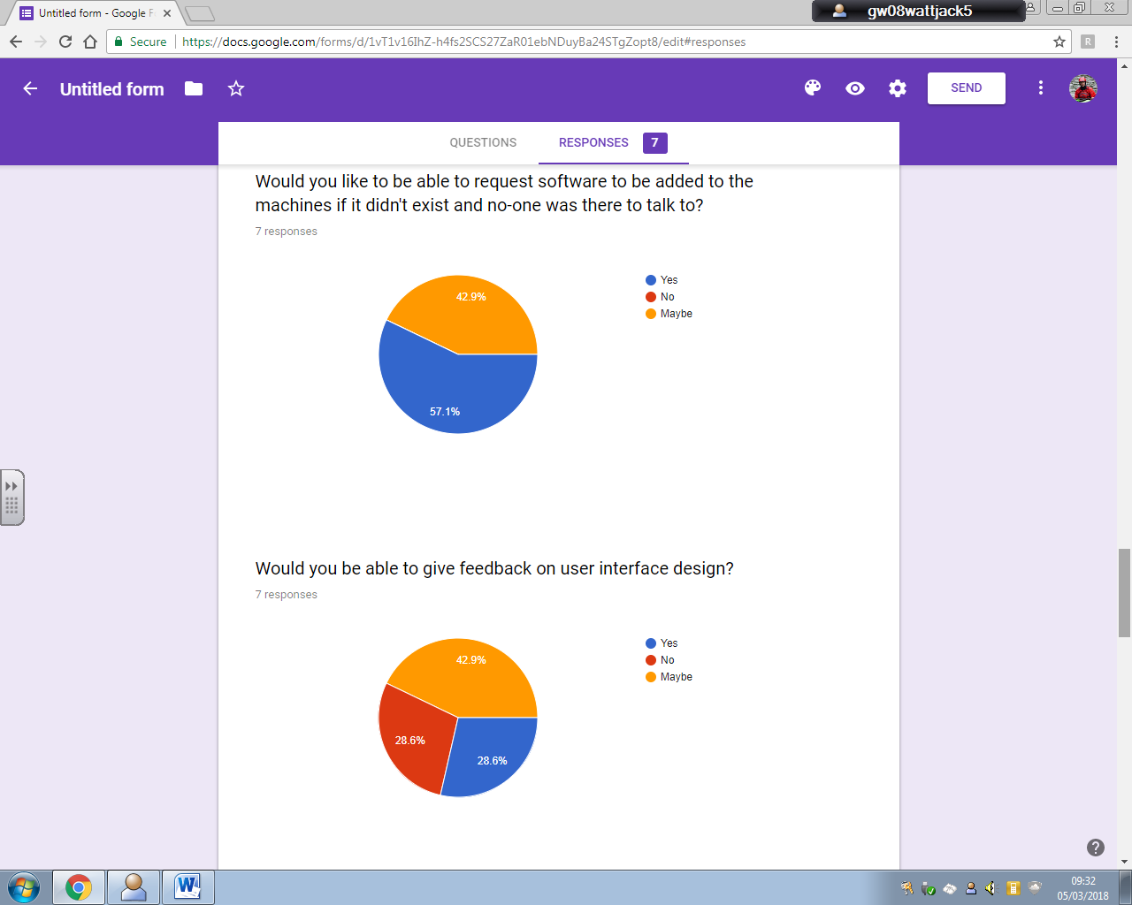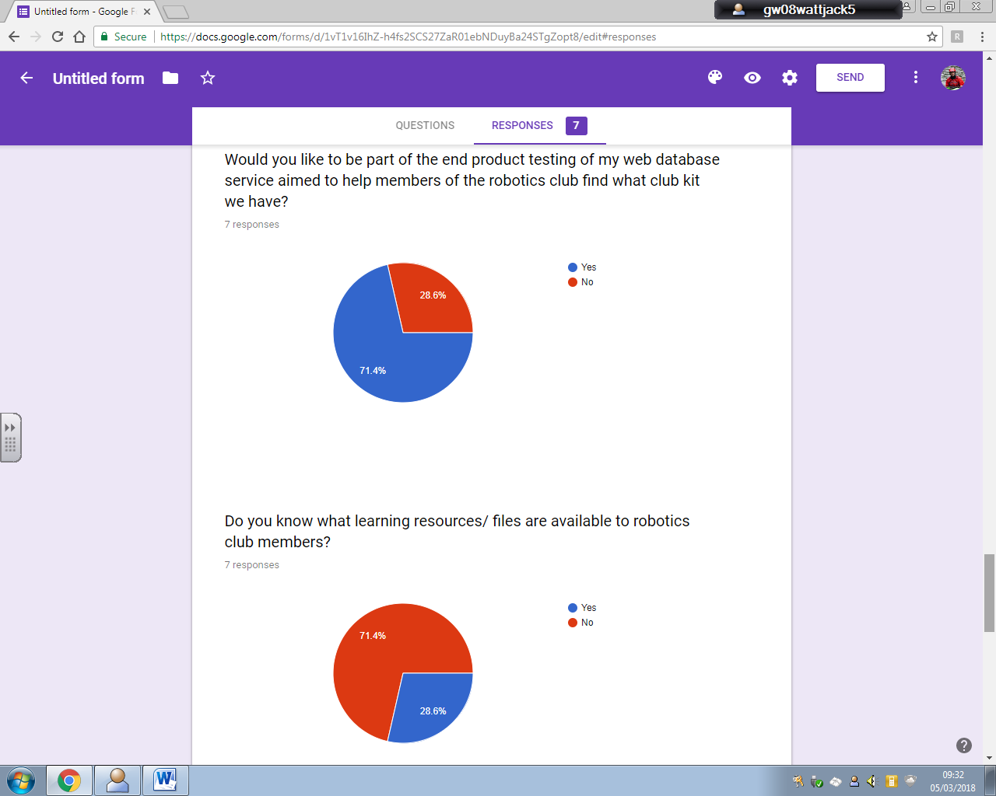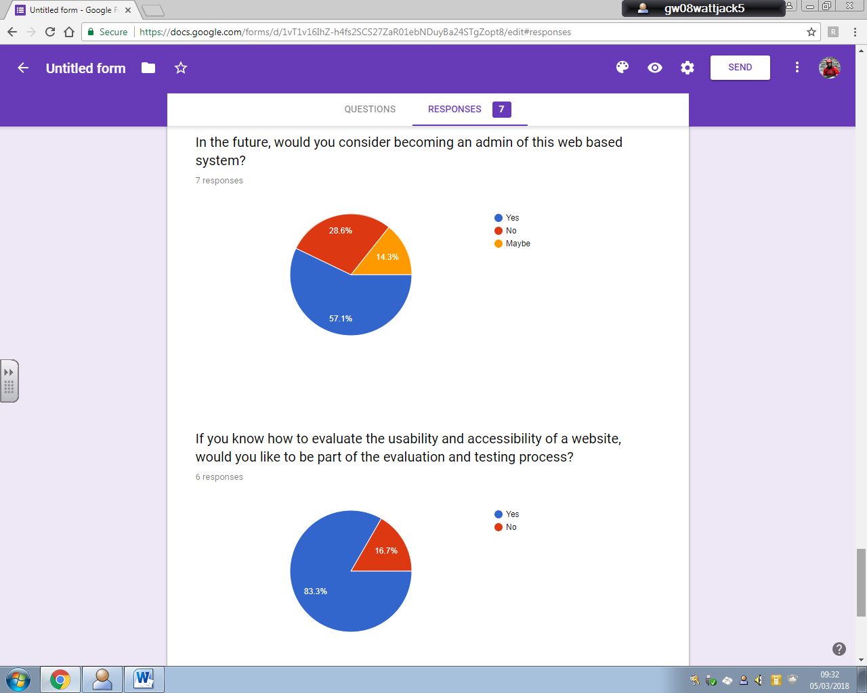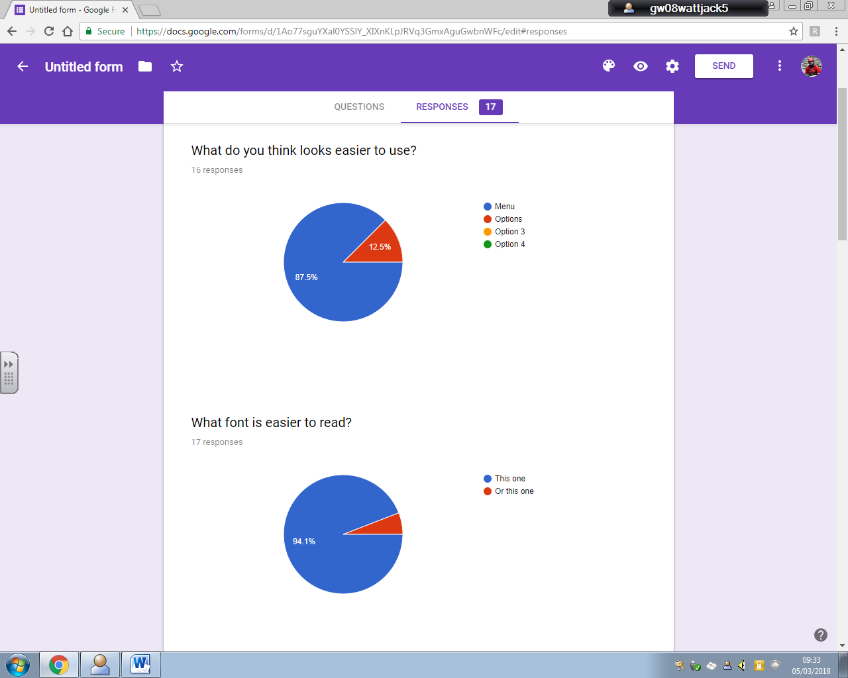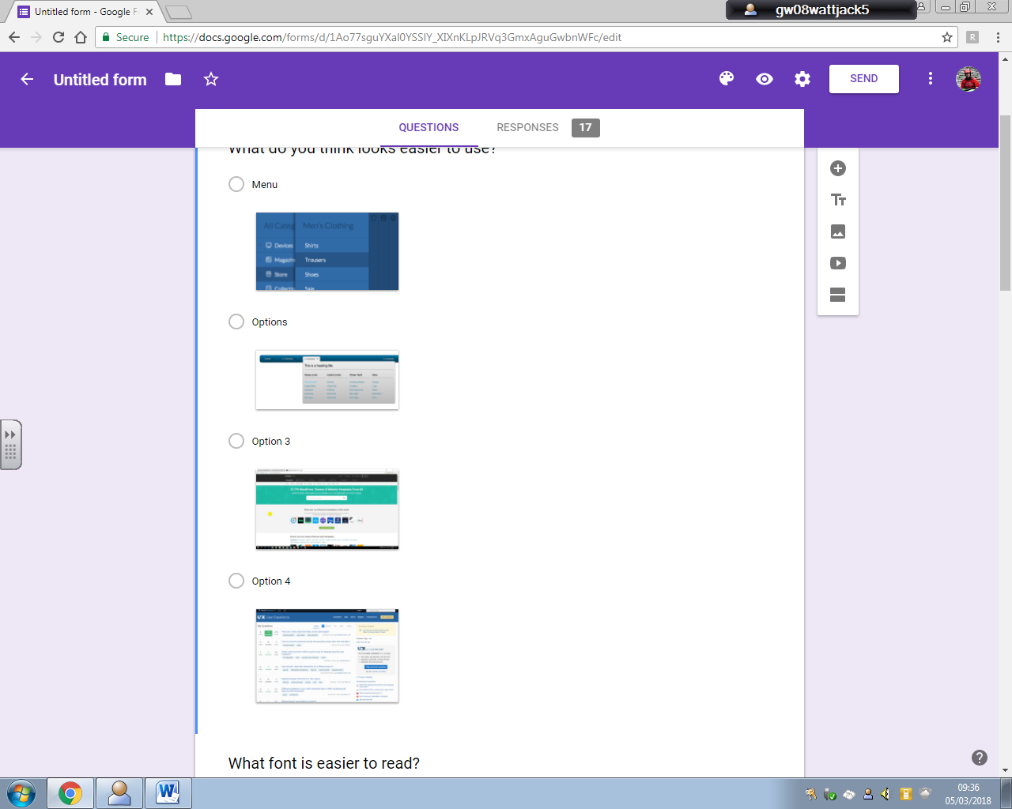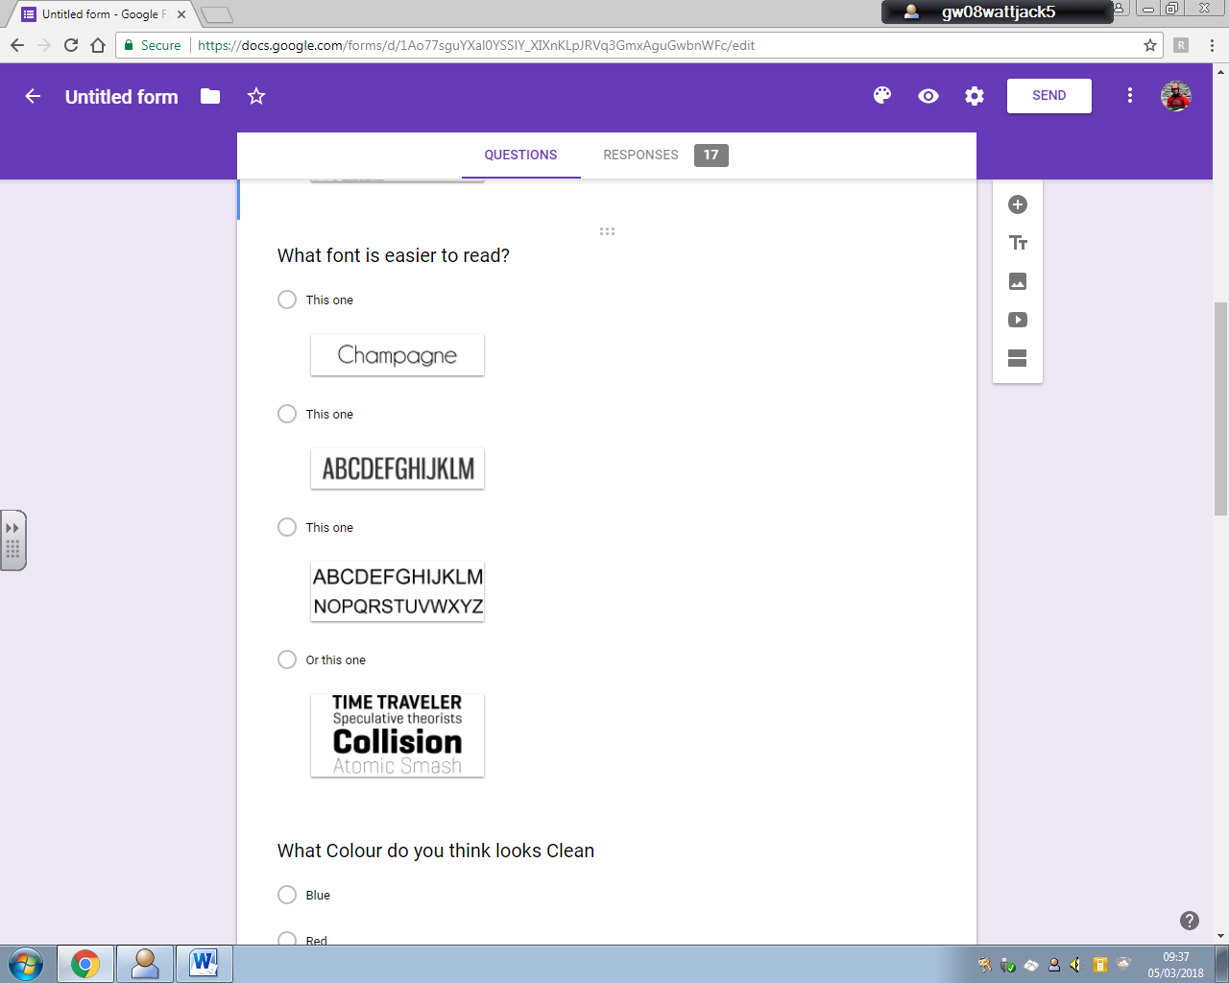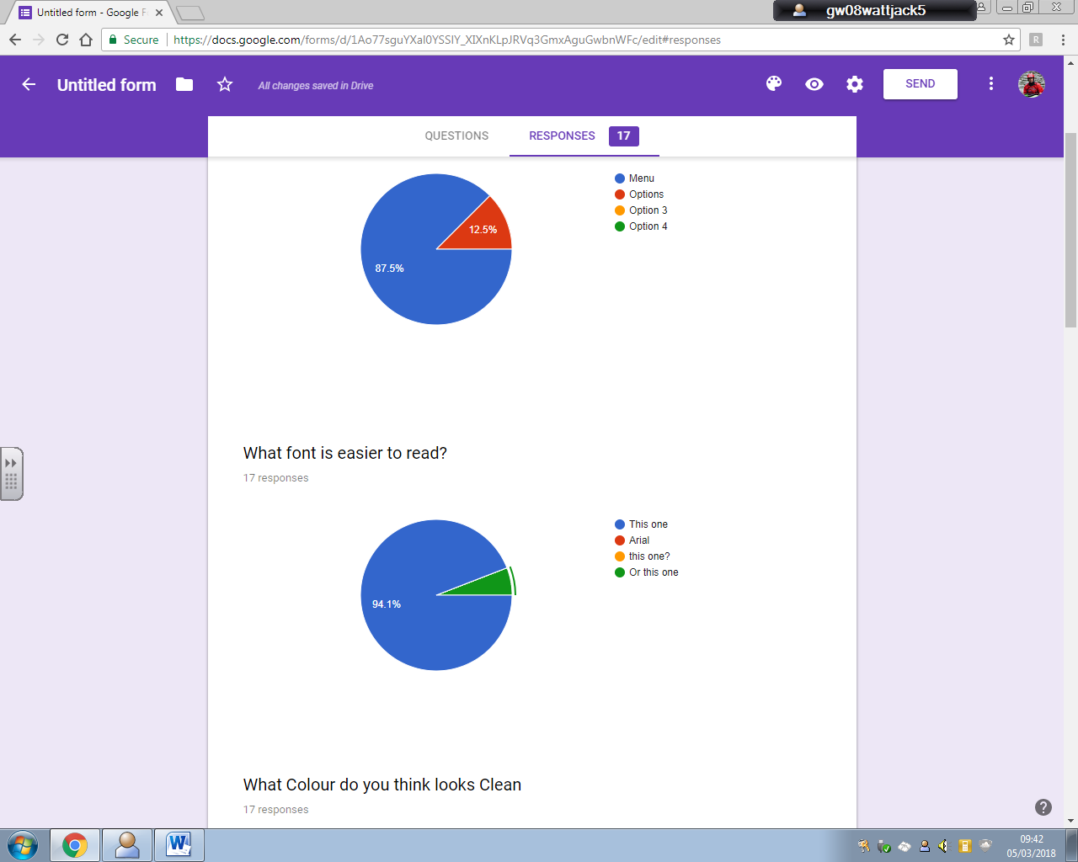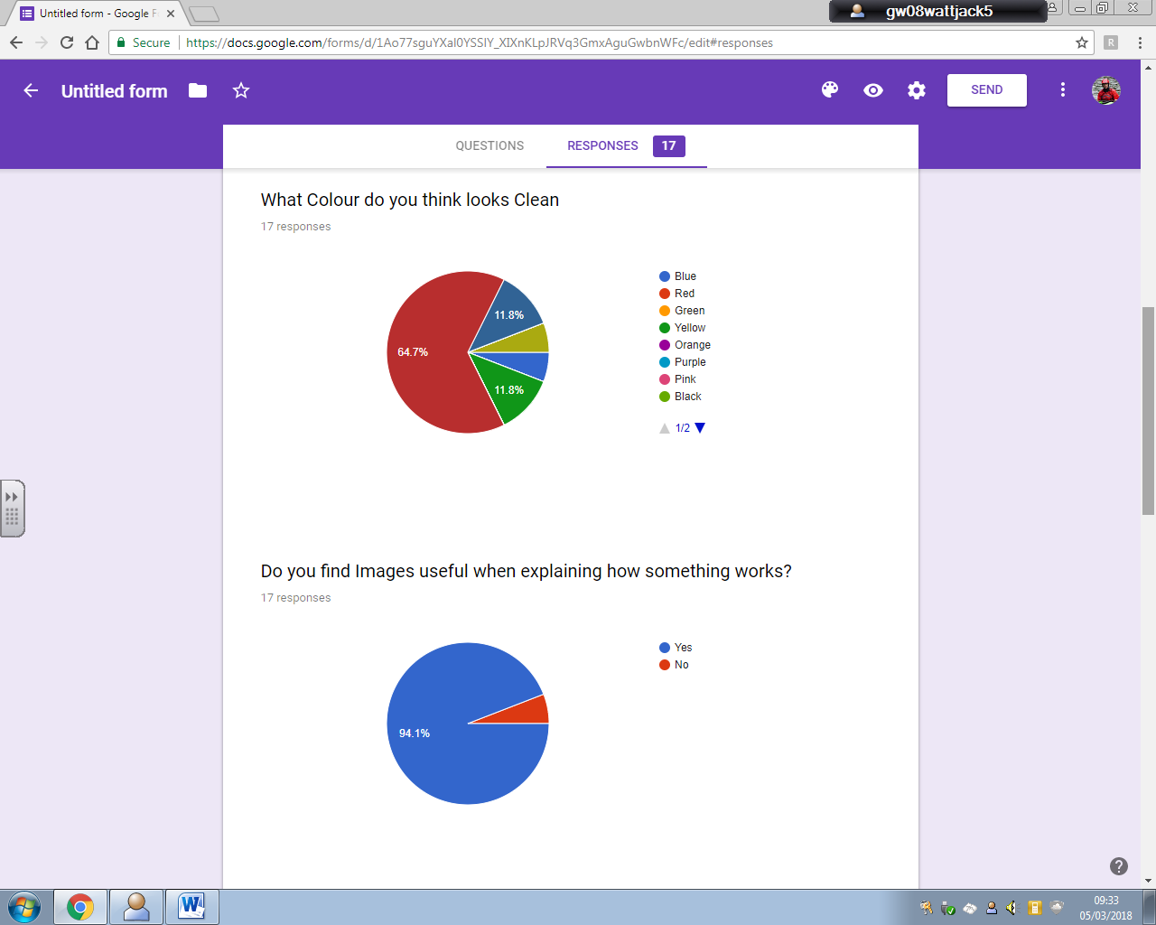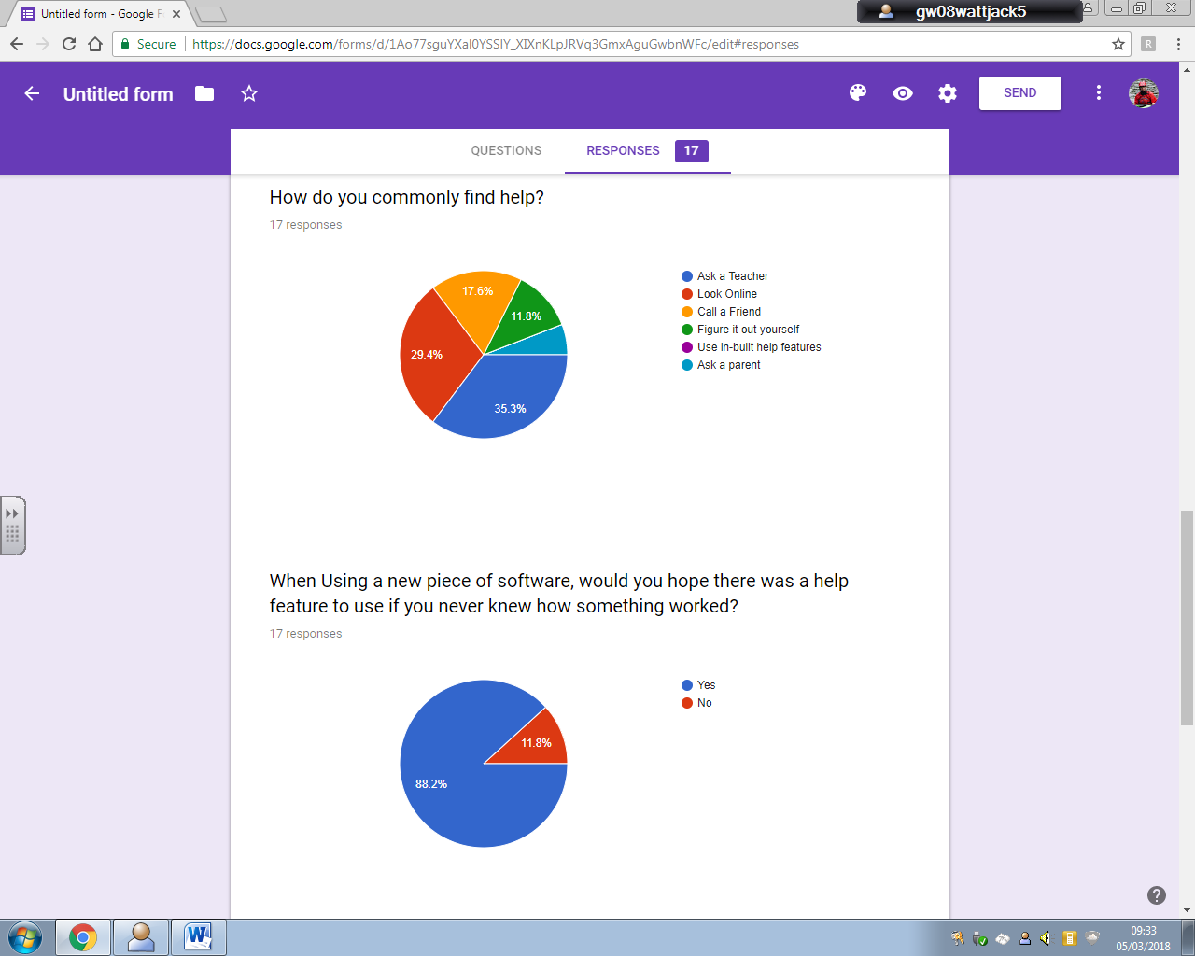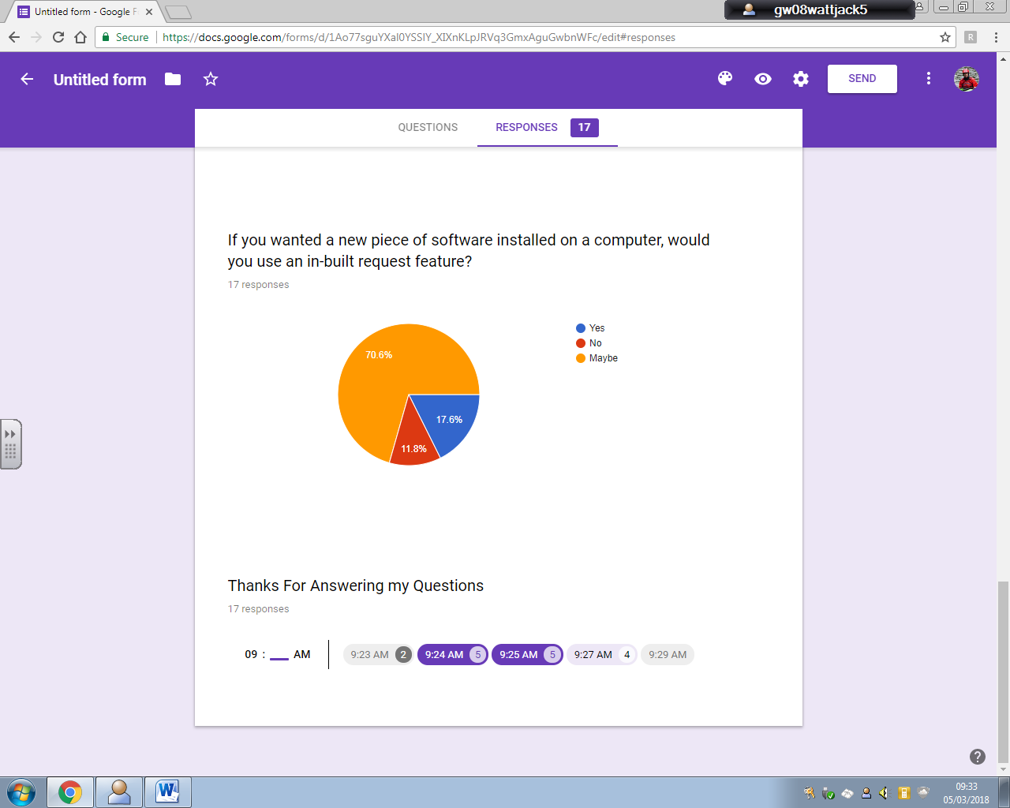

## User Response Analysis

It was noted that most end users have an idea about what the club itself has but they would like to have more available and easier way to find out what there is.

All the End users also expressed that while they have enough knowledge to be able to use the system even though a help and simple user interface would be used.

There is also interest in a logging system for data and software that is wanted on the system which would be web based.

While 57.1% of the club have an idea as to what kit the club has, but 85.7% have acknowledged that they would find it much more useful to have a database with kit listed so they can see everything the club has and in more detail.

There is a general response of 57.1% saying that they would like to see more kit ordered for the club. A database system in this case would ideally allow members to find kit the club does not own so they do not order kit already existing.

All of the Club members find that the school system is very restrictive, and this includes a lack of software they would like which the system would hopefully be able to provide or make available for members to request which the club members in majority agree should be available.

Around 85.7% of the club know of the pre-installed network and 57.1% know how it was made eliminating the need for extensive detail on how the network was setup but providing enough for new members to learn if they would consider it..

Finally, ¾ of the club would be eager to help test the site and evaluate it.

As part of a survey of youth school pupils who are of the same age as club members, feedback on user interfaces and designs provide an insight into how the website should look to make it easy and useable.

87.5% though that he Side, pull out menu looked easier to use that a traditional drop down or other navigation techniques.

94.1% of the youth survey recognised the Champagne font to be easier to read.

64.7% said that Red as a colour looked clean/tidy with 11.8% choosing blue and yellow as well where other colours in the spectrum were deemed to be less clear or associated with mess.

Asking a parent and looking online took the majority votes for the main ways to ask for help. Therefore, hoping to capture the attention of the 30% online users would be the in-built help feature highlighting the main features of the website as 88.2% of the survey would hope there was a help feature available.

88.2% of the survey was keen or unsure whether or not they would like an in-built request feature in the context of getting help online. In the case of the robotics, this meant that the request feature might only be used by admins to get things logged rather than the main set of users accessing the feature.

## End User Requirements

From the survey and project proposal ideas, this list contains a list of features to be featured in the project;

* A Inventory Database
  + Kit Table
  + Software Table
  + File Table
* Simple Forms for Database Queries
  + Kit Table
    - Queries
    - Admin Table Amend Form
  + Software Table
    - Queries
    - Admin Table Amend Form
  + File Table
    - Queries
    - Admin Table Amend Form
* Linear documentation page navigation with page numbers at top to skip to specific pages
* Easy site navigation
* Simple user interface and Design
* Multi machine single user data access
* Upload and Save onto a User database on the server
* Report Issue/Admin Request Feature
* Detailed Information on the system
* Help/tutorial feature (quick)
* Xampp and Apache Service

## System Research

A distributed database was considered for this project, where the database storage mediums are part of different sets of hardware attached to separate processors. This means that the database can be all across the world but have to work together through organized network servers, decentralized independent computers on the Internet or on corporate intranets.

The distribution of the data is spread across the network of database servers at different physical locations. Distributed databases can improve performance for users by allowing transactions to be processed on many machines, instead of being limited to one which decreases the load a single machine and processing time for a single request is faster as less resource allocation is required when dealing with different requests concurrently.

However, due to the scale of the task and the volume of traffic expected to Pass through the server, this was considered to be overpowered and unfeasible as not only was the software unavailable, the current deadline for the project would not be met as it would take too long and keeping data up to date is important since data integrity can be lost requiring specialised software to identify changes across the network and then updating all other databases.

So a traditional single server database system was chosen as its maintenance and implementation are far more suitable the current time available and make use of software already available.

## Feasibility study

### Legal

None of the website or databases will draw from sources other than club created content removing the copyright issue factor from the final system.

There is no personal data being stored and as user accounts are standard and created by an admin, there is no need to regulate the data under the Data Protection Act however its protection as an asset is a concern.

Passwords and Usernames will be in place to prevent unauthorised users gaining access to the system naturally discouraging computer misuse.

System communication with users is strict and prevents data being read by other users as well as barring bad reports into the system from external users.

There are no security threats from external sources since there is no internet access and therefore only hardware vandalism and members with intent to be malicious will be able to attempt to sabotage the system hence why user permissions set by the admin will regulate the system users’ ability to perform certain commands.

### Technical

The level of programming required is not beyond the capabilities of the programmer and the hardware to perform the tests and implementation is low level and already in place.

There was a need to establish our own private network for the club to allow software to be run without the restrictions in place from the Local Authority as well as trial new software.

I decided that this network would host the club inventory software on this private network.

Setting up this Physical Network required;

* 1- 8 port Unmanaged Switch
* 6- HP Compaq dc7900 SFF PCs
  + 4 - Running Windows 7 Home
  + 2 - Running Windows 10 Home
  + Intel Core 2 Duo E8400 @ 3.00GHz
  + Intel HD Graphics 4600
  + 4 GB of DDR2 RAM
  + 64 Bit Architecture
  + 500GB HDD
  + Varying monitors of HP, Ilyama and Belina
* 1- Raspberry Pi – B
  + 4 USB 2.0 Ports
  + Ethernet Enabled
  + Samsung 16” Monitor
* 1- Acer Predator
  + Running Windows 10 Home Premium
  + Intel i7-950 @3.07GHz
  + 6GB DDR3 RAM
  + Nvidia GTX 470 Reference
  + 1TB HDD
  + 4 USB 2.0 Ports
  + 2 USB 3.0 Ports
  + 1 eSATA Port
  + Dual Ethernet
* Xampp and Apache Server Side Hosting Software
* Web Authoring Package (Notepad++)

The Network is setup with 8 Devices connected to the unmanaged switch via 8 Cat5e cables enabling 1GBit Ethernet both ways.

Any of the ports in the switch can be hot swapped with new devices to allow them to be connected to the network but in order to do so, the new device would have to be configured with a manual IP of 10.1.1.# and IPv6 Disabled and a manual network mask of 255.255.0.0.

The Network design is a Star network like so,

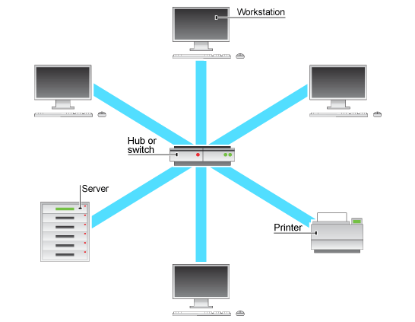

This Setup Shown has the Server PC as 10.1.1.1 and the Printer as 10.1.1.100 and the first 6 PCs connected already are 10.1.1.2 through 6.

The printer is a Xerox Phaser 3610 but only the 3 Windows 10 PC’s have the correct drivers installed.

All Windows PC’s required network discovery to be turned on and have a Script I created in the start-up folder so that when a user logs in, it maps a network drive to the Server Machine for file sharing under a virtual user called shareuser.

5 User accounts have been created identical to each other using a bat script and an admin account is enabled and named localadmin across all machines.

That is the network setup with physical and digital configurations.

### Economical

All of the hardware provided was free from Robert Gordons University and software installed has been provided for free or is open source. The network also is running inside the school so therefore the cost to the client, AARC, is £0 since there is no running cost, setup costs involved or space rental costs.

### Schedule

The project should take no longer than three months. The System should be fully implemented and be under test before the required deadline so that the completed system can be fully evaluated by the users and reported on before the final deadline.

# Project Plan

### Task Management

The System specification must be completed before system design and test plan is completed.

The Designing and Test Plan Development can be completed concurrently.

The Implementation of the System cannot commence until the System design is completed.

The Testing of the System can begin after most of the Development has been completed.

The User Testing (Beta) cannot begin until the Alpha testing has finished.

The Release evaluation cannot be completed until the Beta testing is over.

Final Deadline is 20th of April.

### Deadlines

Test Plan - 05/03/18

Design Phase- 09/03/18

Implementation Phase - 06/04/18

Alpha Testing Phase - 06/04/18

Beta Testing Phase - 19/04/18

Evaluation and Documentation Phase - 20/04/18

### Schedule

### Resource Management

Files will be kept in 3 places, on the server machine, a USB drive and a second PC as a backup. This can ensure that there is not a loss of progress.

A selection of reference documents will be kept on a shelf behind the server for use while implementing the design.

### Barriers and Alternatives

Significant barriers to the development process is that the Local Authority doesn’t allow us access to setup web services within the school or connect to hosted web services out with the school.

The alternative was to create an in house server/service provided to an intranet of machines with no external connection to ISP’s or Local Authority Servers.

# Specification

The whole system is designed for the members of the robotics and coding club to be able to access and see the details on club stock, inventory and resources available to use. This will provide them with details such as the last time the inventory was checked alongside the ability to upload their files, code and software to the service. This will be a database driven service.

It will also make available the tools for admins to alter and amend the databases and manage the server for dealing with request from users and any bugs that might be thrown at them.

The Server will be a GUI web interface hosted on a server machine providing users access to the database.

Inputs:

* Files
* Kit Data
* Software data
* Search Criteria
* Sort Criteria
* Admin Password
* Error Reports
* Screenshots
* Text Input
* Dropdown menu Selections

Output:

* Kit Table Data
* Software Table Data
* File Table Data
* Network Documentation Pages
* Error files on Server Desktop
* Help Overlay

* Basic user database queries

These will allow the users to be able to query the AARC database for their specific search.

The files will allow club members to download shared files to make copies of.

It will take search items and a sorting type before displaying the results.

The sort will be by field and will be manually programmed.

* Admin user database amend form

These allow admins to add new kit to the database as well as alter previous entries provided they know what they are looking to alter.

It will also be able to display contents of tables so that the admins can review current data in the tables before deciding to alter the contents.

* Admin log in feature

This feature will allow the admins access to the Amend and Alter forms used to update the database provided they have a Password that matches the admin Password.

* File Upload Feature
  + Table interface form
  + Save file feature to a server library
  + Table auto update with file details

This will allow club members to upload files they have created or altered to the file table and server file library. The Files uploaded will contain all the details the PHP will require to update the table without the user having to add anything other than their name.

* Home Page
  + Navigation Bar
  + Left side pull out

These features will allow a brief overview of the web portal and its features as well as a good structured way to access each page and its contents including database forms and network documentation.

The user will only have to select an option in the menu to navigate to the page required.

* SQL Table for Kit, Software and Files
  + In AARC Database

These tables and database will store the contents of the AARC inventory of all software, files and kit. It will provide the web based users’ access to the contents as well as admins the ability to alter the contents from the web based forms.

* Help and tutorial button with appropriate guidance on how to use the site
  + Home Page
  + Table Query Page/Forms
  + Login Forms

These features will provide a detailed breakdown of each element of the site including how each item works as well as what it does.

The JavaScript will blanket the page with a semi-transparent layer only revealing each item as they are being detailed.

* Documentation page with basic network setup details
  + Linear Page layout
  + A4 size Documentation

This linear navigating documentation set will allow a quick overview of the network and its build as well as contain images/relevant animations so that interested users can see the network setup and the database setup so they can build their own or maintain this one in the future.

* Admin report feature to log issues
  + Text input and screenshot attachment

This will be a Form allowing the system users to log errors and make requests for software etc, without the need to find another human to ask.

It will contain the ability to note down issues, add screenshots or add software installation files so that the admin can access each request from the server machine. They would be stored as rich text format documents to allow screenshots to be stored as well as have an auto generated file path for any uploaded files.

# Test Plan

Red Text – New Information only gained during the implementation stage

Blue Text – Confirmed information during the Implementation Phase

|  |  |  |  |  |
| --- | --- | --- | --- | --- |
| Test Area | Test Item Set | Test | Requirement Fulfilled | End User Testing |
| User Interface | Home Page | Navigation Bar  Rolls out on hover | Easy User Interface Design | Visual Feedback |
| Internal Links  Links work Properly | Web Navigation | Written Feedback |
| Image Display  Loads correctly | Easy User Interface Design | Visual Feedback |
| Usability  Users find it easy to use | Easy User Interface Design | Written Feedback |
| Admin Page | Login Form | Login for Admins | Trial Use |
| Form Usability | Easy User Interface Design | Written Feedback |
| Form Clarity | Easy User Interface Design | Visual Feedback |
| Database Table Display | Stock and Inventory Display | Visual Feedback |
| Network Page | Page Links | ***Suspended from project!*** |  |
| Document Text Size |  |  |
| Upload Page | Form is easy to use | Easy User Interface Design | Written Feedback |
| Allows user to select any file | File Upload System | Trial Use |
| Provides feedback for user on PHP decisions | User Reporting/ Feedback | Trial Use |
| Request Page | Alerts user to whether or not they can submit a report. | User Reporting/ Feedback | Evaluation of System |
| Database | Club Database | Whole database supports read, write, and queries. All tables are referenced correctly. | | |
| Request PHP | Request Form | File Upload Success | User Reporting/ Feedback | Evaluation of System |
| User Details Noted | User and System Security Checking | Trial Use |
| File Creation | Reporting Error or feedback system | Trial Use |
| File Write | Reporting Error or feedback system | Written Feedback |
| Help JS | Home Page  ***Suspended from project!*** |
|
| Network Page |
|
| Report Page |
|
| PHP | HTML and Processing | Password Censorship | User and System Security | Visual Feedback |
| Forms Not displaying untill required or without correct permission | User and System Security | Evaluation of System |
| Password Submission Validation | User and System Security | Trial Use |
| File Handling | Moves file to correct location | System operation | Trial Use |
| Updates database | Data Integrity | Trial Use |
| Validates users correctly and provides information to user | User and System Security | Trial Use |
| Upload/  request/  database Forms | Form | Has all fields for input! | Easy User Interface Design | Visual Feedback |
| Validates and has correct Input types | System operation | Trial Use |
| PHP File Handles | Allows to browse for file | File Upload System | Trial Use |
| Creates and writes to file properly | File Upload System | Visual Feedback |
| SQL Database Updates | Updates tables without damaging data integrity | Data Integrity | Visual Feedback |
| Data is deleted or amended properly in fields | Data Integrity | Evaluation of System |
| HTML and PHP data transfer | HTML hand off text to PHP for file creation | Reporting Error or feedback system | Visual Feedback |
| PHP writes to files and saves them | Reporting Error or feedback system | Evaluation of System |

# Interface Design

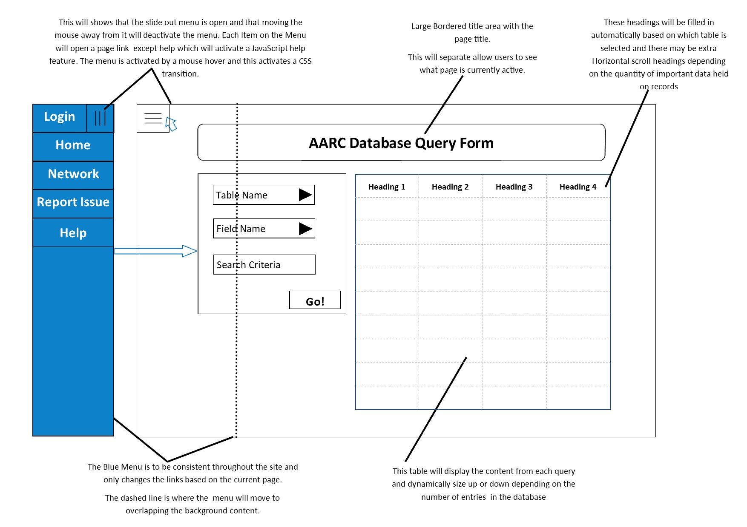



**Admin Controls**

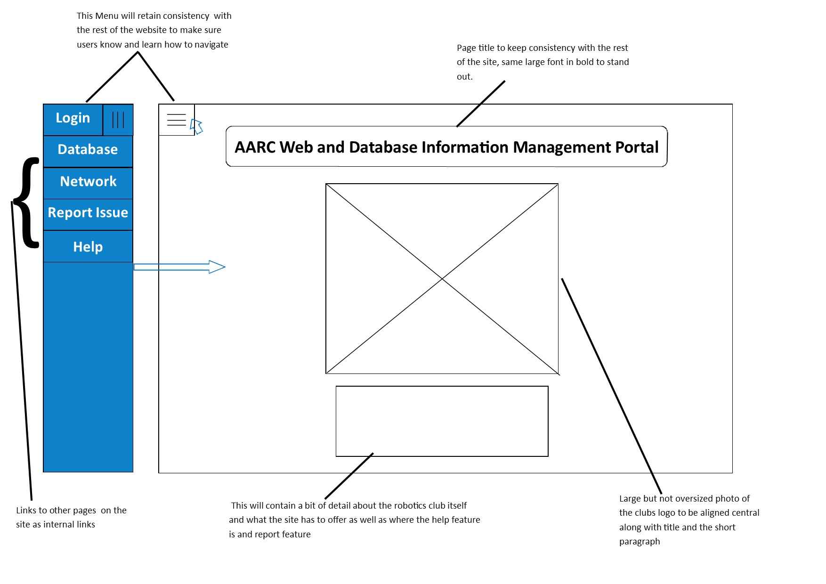



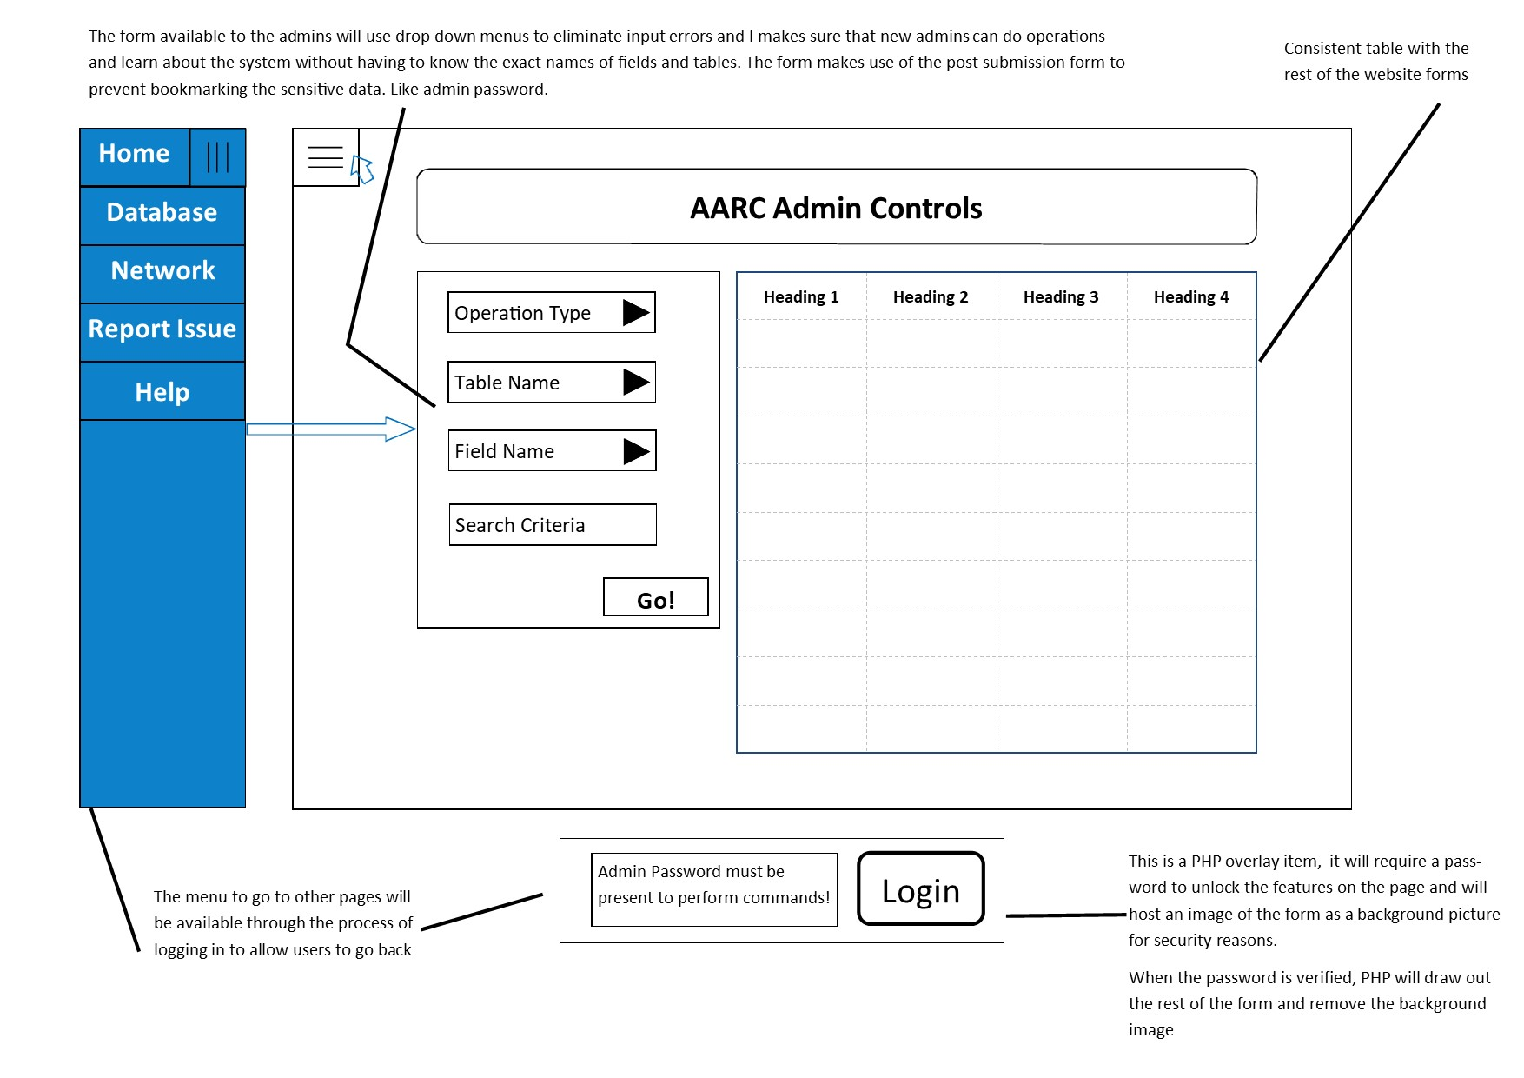





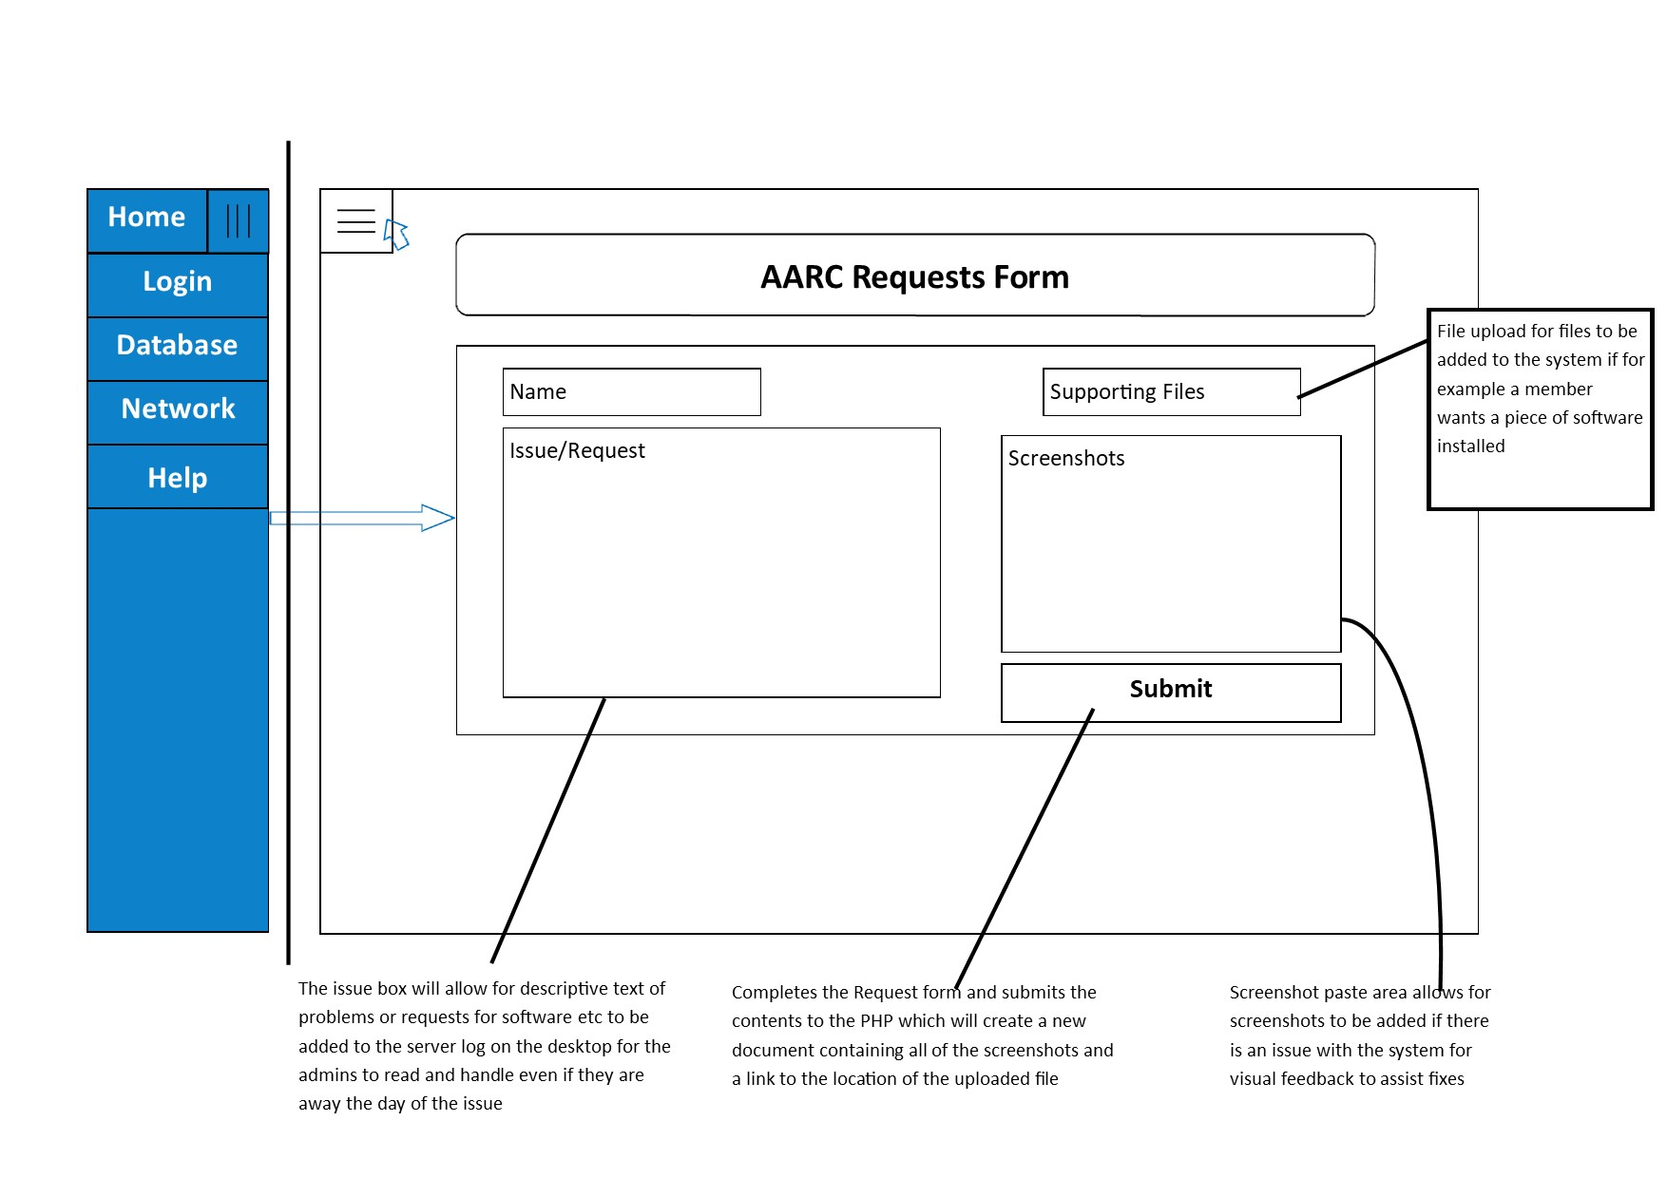



# Program and Data Structures

### Website Navigation Structure

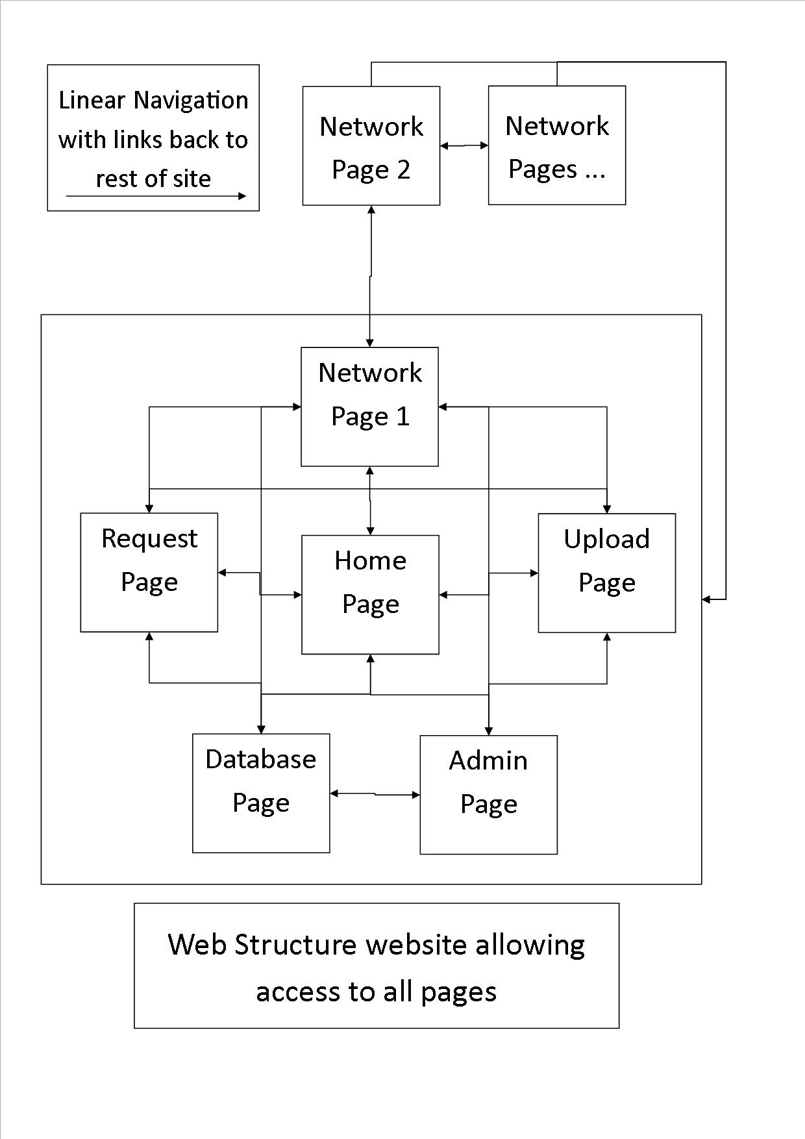

## System data flow diagrams

### Web to PHP data flow

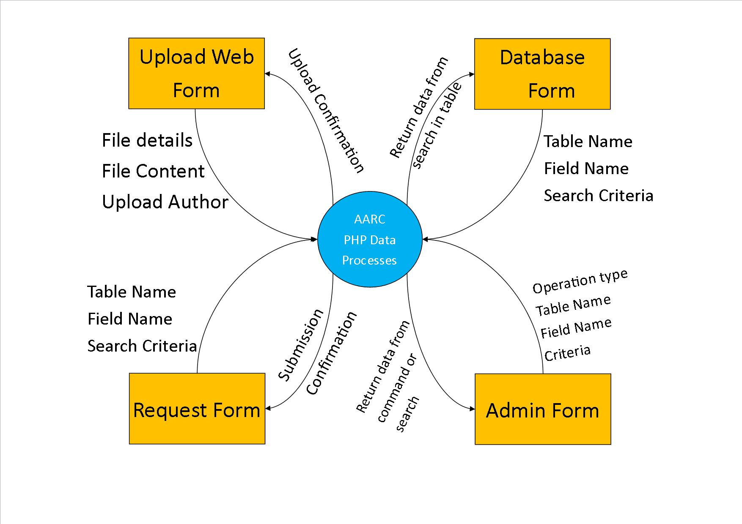

### PHP to MySQL data flow

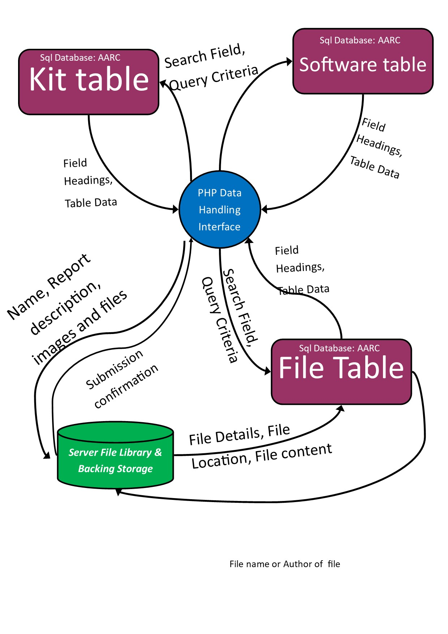

## Data Structures

Validation can take place in 3 ways; by JavaScript on the client side, SQL on fields which feedbacks through PHP or PHP validation which is more of a waste of time as SQL will validate anyway. However there would be a need to handle SQL Errors if the data isn’t validated so using JavaScript, a html form can have client side validation and that would mean that only internal SQL errors are needed to be accounted for.

The database is being cross reference and tested with Microsoft access as it’s a powerful tool to help validate inouts and able types. Any created tables are t

### SQL Data Dictionary ResourceT

|  |  |  |  |  |  |  |
| --- | --- | --- | --- | --- | --- | --- |
| Field | Type | P/F Key | Format | Auto Increment | Required | Default Value |
| TypeID | VARCHAR(15) | PK | 3 characters of Name & 4 numbers | - | Yes |  |
| Name | VARCHAR(30) | - | - | - | Yes |  |
| Location | VARCHAR(255) | - | - | - | Yes |  |
| FileSize | INTEGER | No | ###KB | - | No |  |
| Filetype | VARCHAR(8) | No | .### (.exe) | - | No |  |

### SQL Data Dictionary InventoryT

|  |  |  |  |  |  |  |
| --- | --- | --- | --- | --- | --- | --- |
| Field | Type | P/F Key | Format | Auto Increment | Required | Default Value |
| ID | INTEGER | PK | - | Yes | Yes |  |
| Qty | INTEGER | - | - | - | Yes | 1 |
| Date | INTEGER | - | Short date – (09/06/17) | - | Yes | (Today’s Date) |
| TypeID | VARCHAR(15) | FK | From Resource Table | - | Yes |  |
| CheckID | VARCHAR(15) | FK | From User Table | - | Yes |  |

### SQL Data Dictionary CheckerT

|  |  |  |  |  |  |  |
| --- | --- | --- | --- | --- | --- | --- |
| Field | Type | P/F Key | Format | Auto Increment | Required | Default Value |
| CheckID | VARCHAR(15) | PK | 2 Name Chars & 2 Numbers | - | Yes |  |
| UserID | VARCHAR(30) | FK | - | - | Yes |  |

### SQL Data Dictionary UserT

|  |  |  |  |  |  |  |
| --- | --- | --- | --- | --- | --- | --- |
| Field | Type | P/F Key | Format | Auto Increment | Required | Default Value |
| UserID | Integer | PK | - | Yes | Yes |  |
| MemberName | VARCHAR(30) | - | - | - | Yes |  |
| Username | VARCHAR(30) | - | - | - | Yes |  |
| Password | VARCHAR(30) | - | *** Mask | - | Yes | Password1 |
| Privilege | Yes/No | - | Yes/No | - | Yes |  |

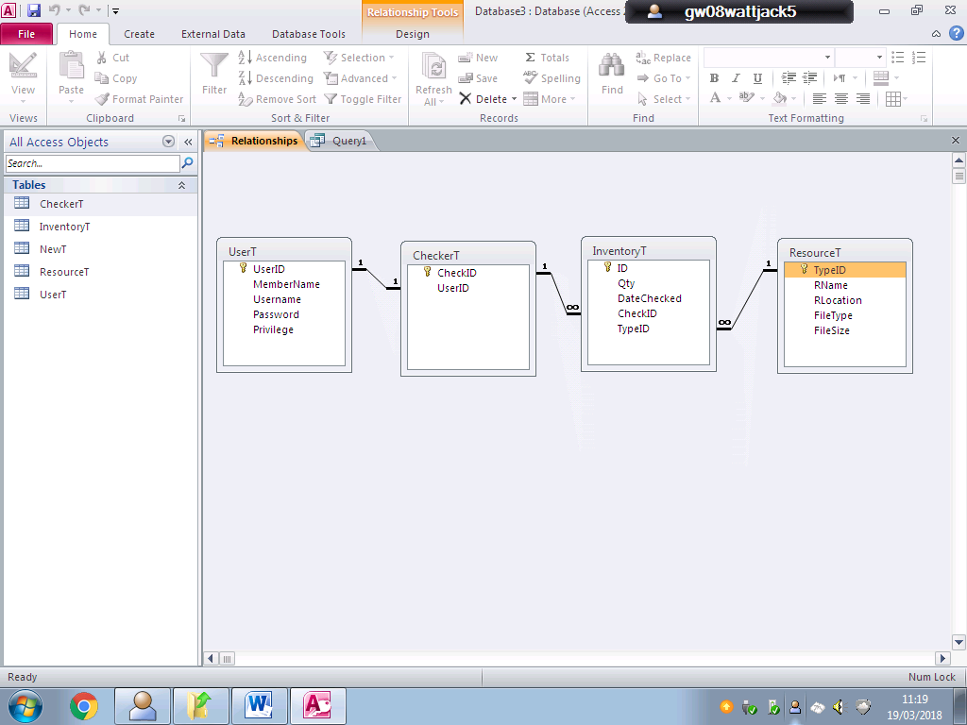

## PHP Data Processes

Page Start Terminators are when the page is loaded

***Report Page Flowchart***

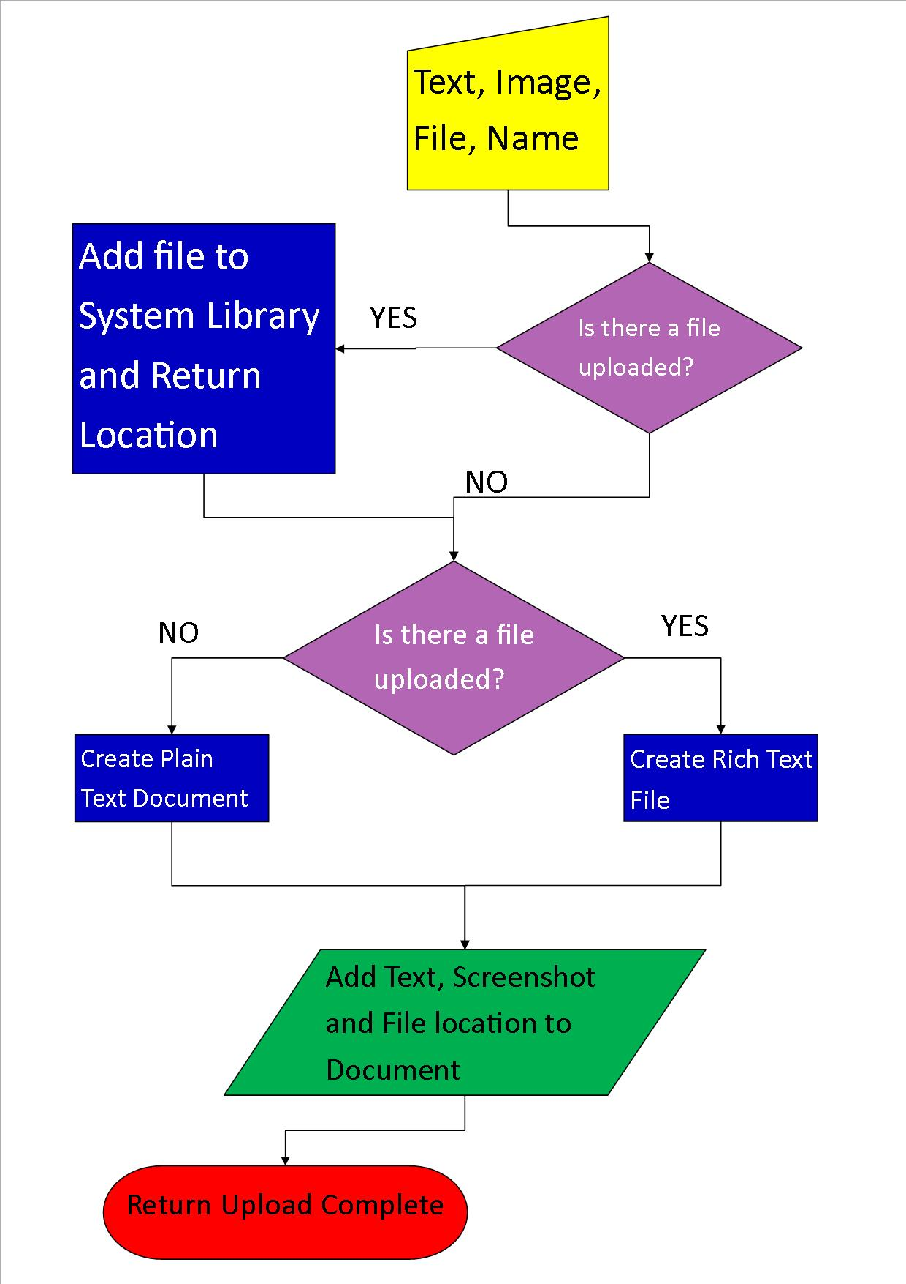

***Upload Page Flowchart***

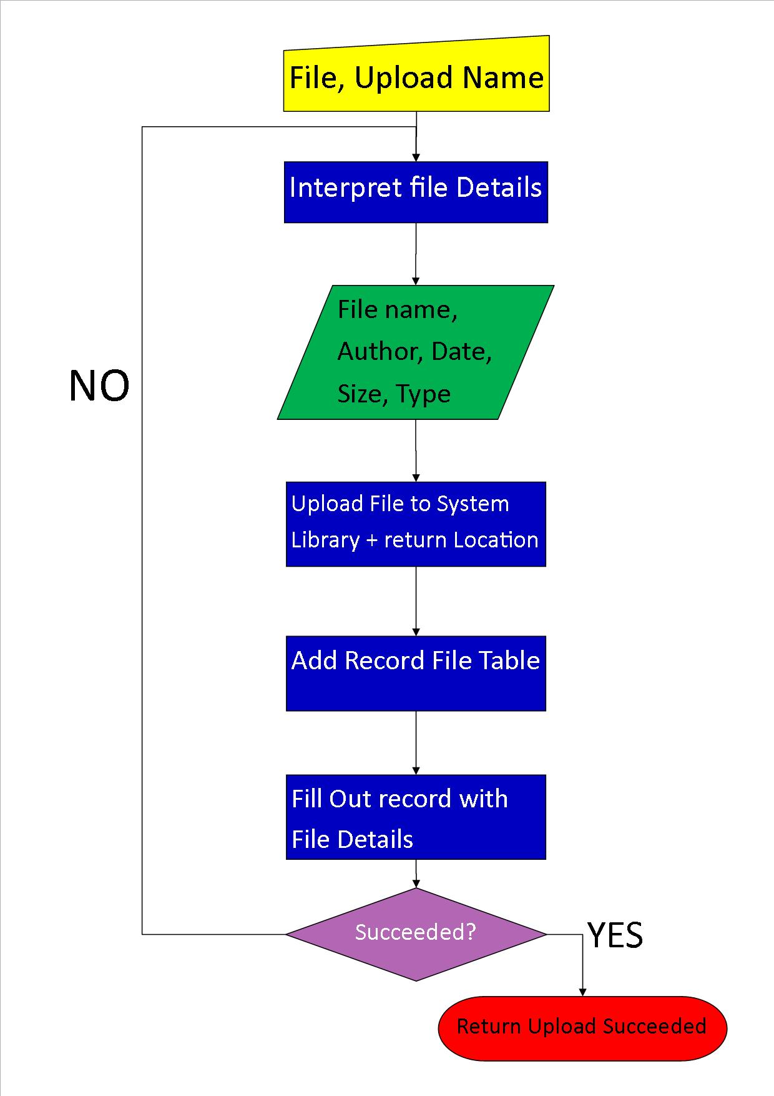

***Admin Page Flowchart***

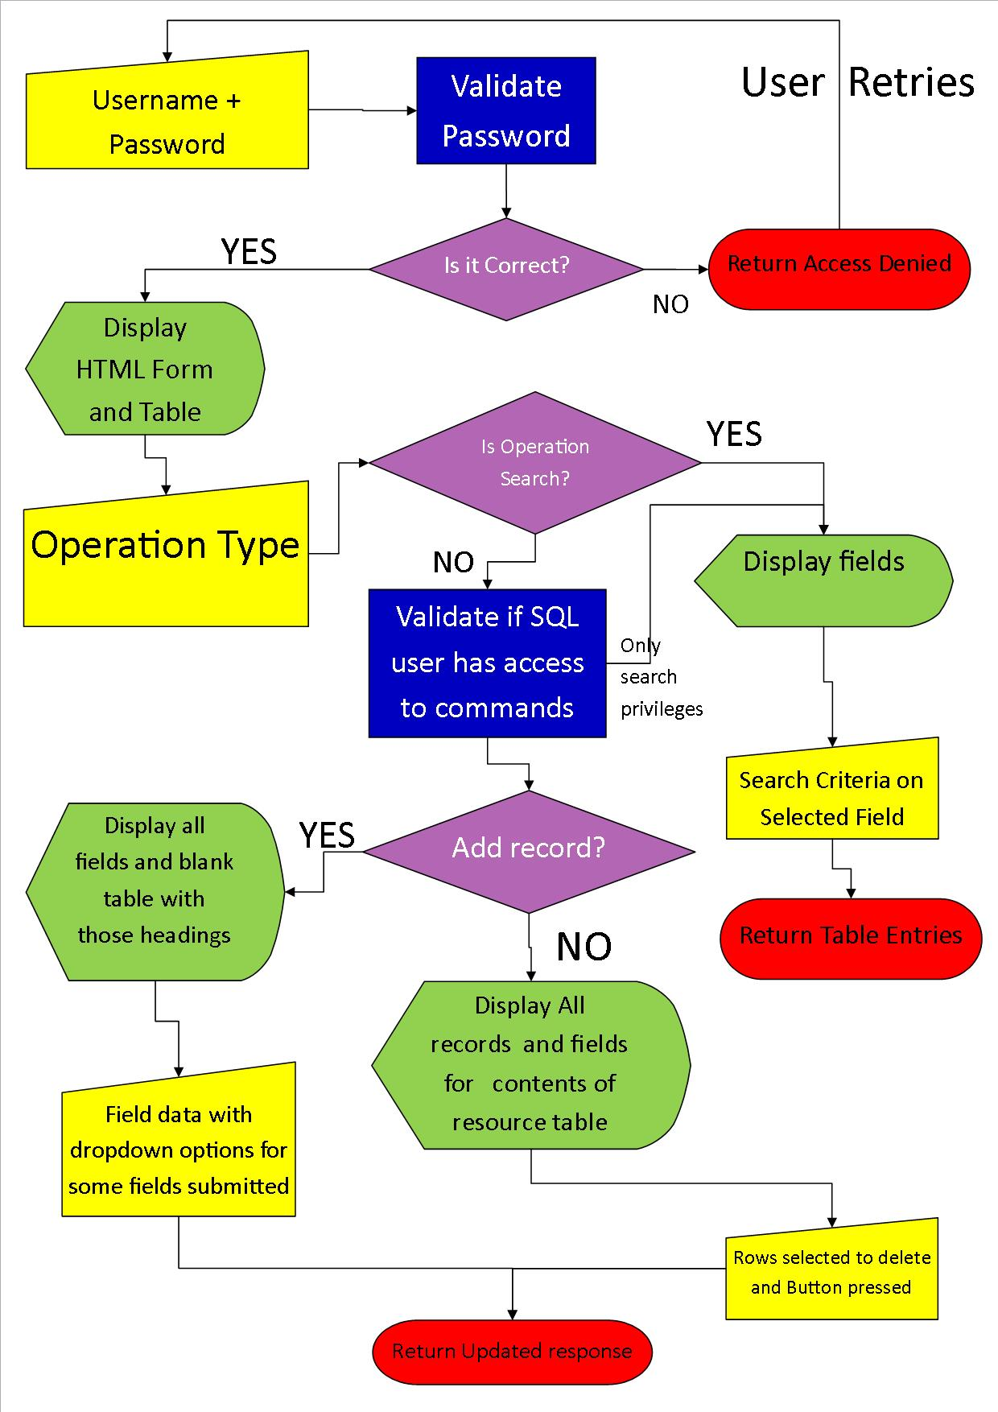

# Implementation

## Access & SQL Tests:

Test using MS Access and PHP My admin were used throughout the project to verify queries as well as build queries quickly MS had this available to use.

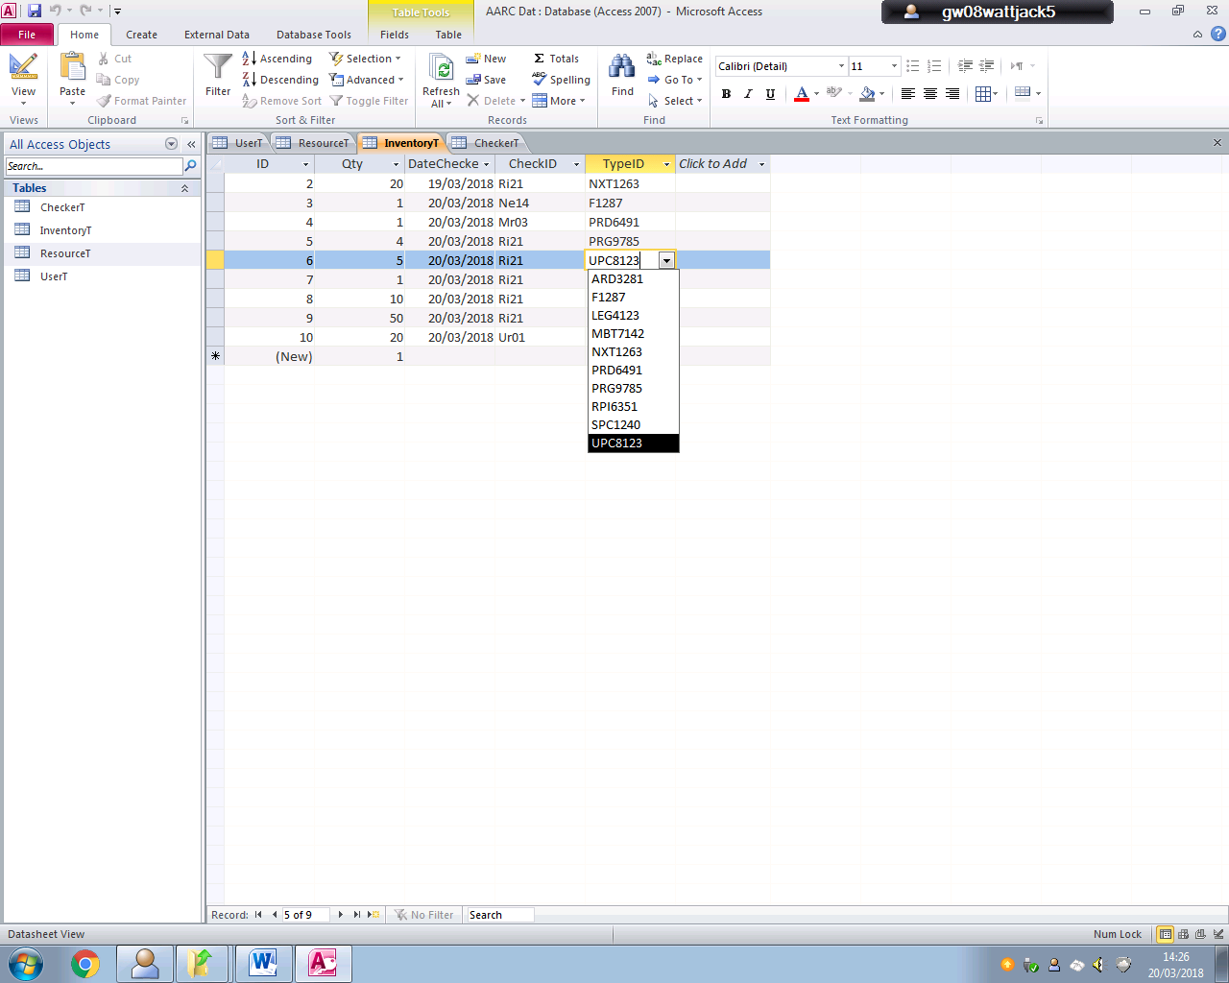 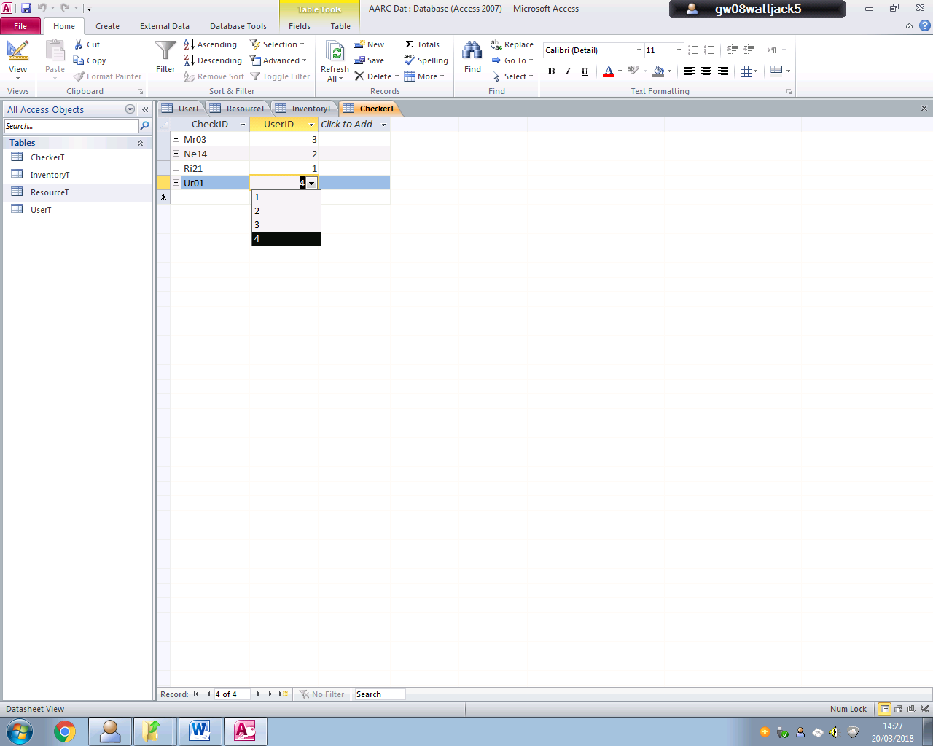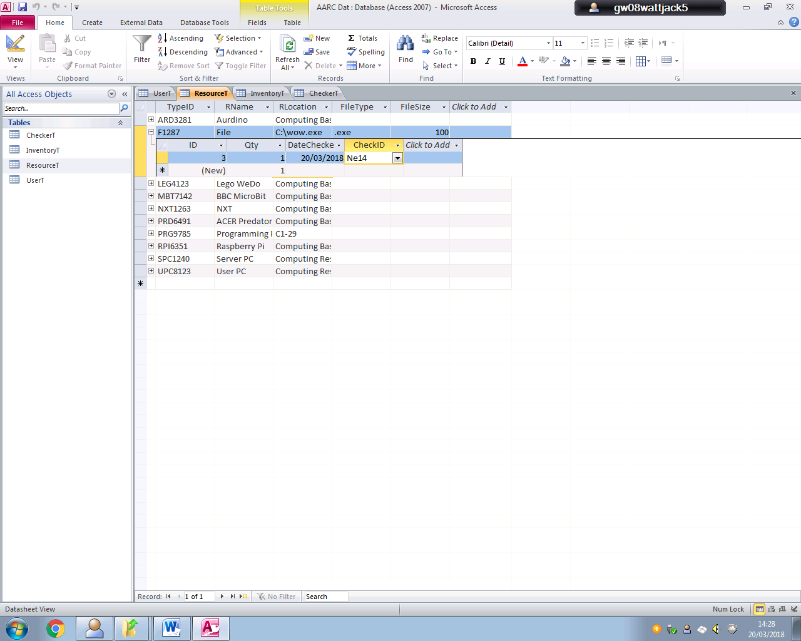

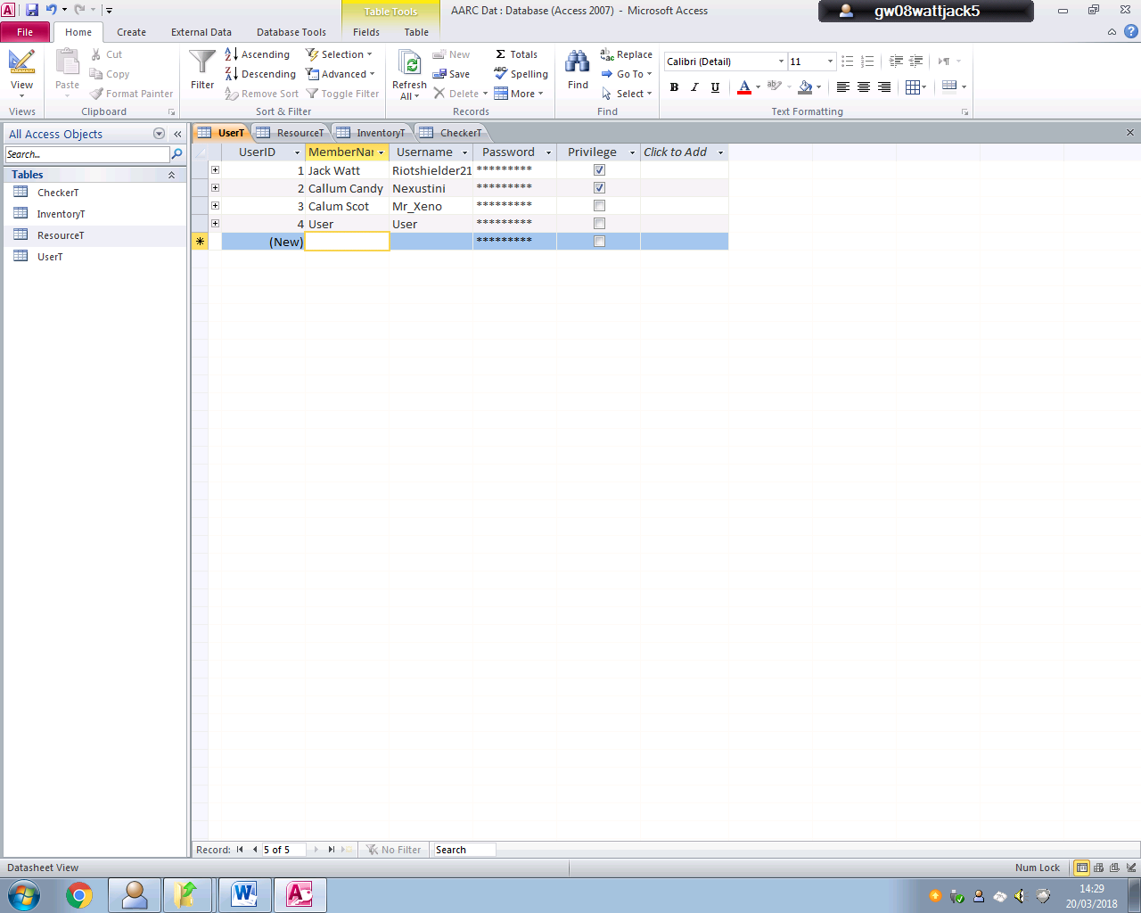

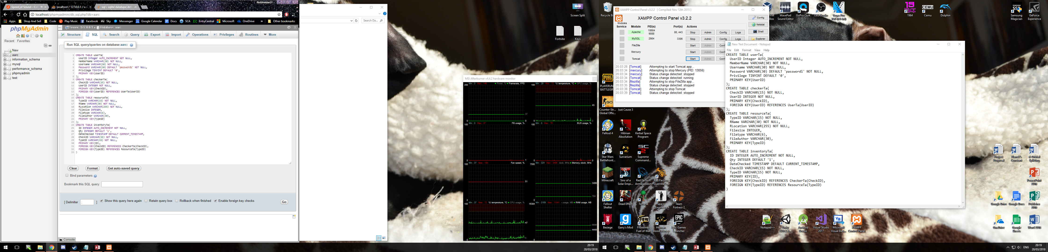

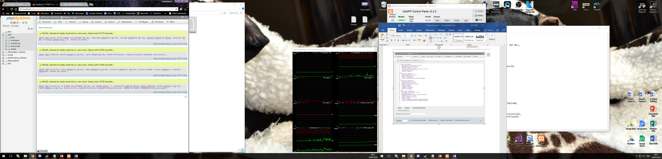

## Implementation Error Change Log;

1. 28/03/18 - Datechecked field of Inventoryta table is now of type timestamp and default value is set by MySQL as CURRENT­_TIMESTAMP
2. 01/04/18 – Resource Table was updated to following structure and Username in UserTa has become a unique field but not primary key

***SQL Data Dictionary ResourceT***

|  |  |  |  |  |  |  |
| --- | --- | --- | --- | --- | --- | --- |
| Field | Type | P/F Key | Format | Auto Increment | Required | Default Value |
| TypeID | VARCHAR(15) | PK | 1- 3 characters of Name & 4 numbers | - | Yes |  |
| Name | VARCHAR(40) | - | - | - | Yes |  |
| Location | VARCHAR(22) | - | - | - | Yes |  |
| FileSize | INTEGER(12) | No | - | - | No | NULL |
| Filetype | VARCHAR(40) | No | - | - | No | NULL |
| Author | VARCHAR(40) | No | - | - | No | NULL |
|  |  |  |  |  |  |  |

1. 01/04/18 – HELP JavaScript feature for each page is being removed from project due to time constraints
2. 02/04/18 – A default custom 404 page has been added to the project to deal with any bad links that are not sorted after testing or undiscovered
3. 02/04/18 – It was discovered there is a bad library or due to an old PHP version that specific SQL commands are not functioning as expected and alternatives have to be used. Examples of these pre-defined functions which were not working are listed in the appendix
4. 02/04/18 – 5 queries across multiple pages did not run due to bad syntax or wrong commands being used. These corrected queries are listed below.

"SELECT userta.UserID, userta.Username, userta.Password, userta.Privilege, checkerta.CheckID FROM userta INNER JOIN checkerta ON userta.UserID = checkerta.UserID WHERE userta.Username = '".$Username."'”

"INSERT INTO Resourceta (TypeID, Name, Location)VALUES ('".$newTypeID."', '".$name."', '".$locat."')"

"INSERT INTO inventoryta (Qty, CheckID, TypeID)VALUES ('".$_POST['RQty']."', '".$CheckerID."', '".$newTypeID."')"

"UPDATE ResourceTa, InventoryTa SET ResourceTa.RName='".$val."', InventoryTa.CheckID='".$CheckID2."', InventoryTa.DateChecked='". date('y:m:d h:i:s') ."' WHERE InventoryTa.ID='".$ID2."' AND ResourceTa.TypeID = InventoryTa.TypeID"

"SELECT InventoryTa.ID, ResourceTa.RName, InventoryTa.Qty, InventoryTa.DateChecked, InventoryTa.CheckID, ResourceTa.TypeID, ResourceTa.RLocation FROM ResourceTa INNER JOIN InventoryTa ON ResourceTa.TypeID = InventoryTa.TypeID WHERE ResourceTa.RName LIKE '%".$sCri."%'"

1. 03/04/18 – Editdata.php page hasn’t been retaining data as expected. This means that no fields on any records are updating and a solution involving cookies or sessions has been investigated
2. 03/04/18 - Editdata.php page still hasn’t been able to retain data _Get from URl and then POST in a form to $_SERVER[‘PHP_SELF’]
3. 03/04/18 – HTML Password input fields are now masked by changing input type to Password rather than text since there is no longer need to test if that feature works
4. 03/04/18 – Upload.php was causing huge issues when uploading files as it was ether creating entries to the database and not uploading or vice versa. It was also not validating user details before uploading meaning unauthorised users would have been able to upload anything to the server.
5. 04/04/18 – Upload.php has had security threats solved as well as having files sorted
6. 04/04/18 - code taken from Upload.php page into the Request.php page wasn’t compatible with the solution and after deleting the necessary code, there is a persistent unexpected end of file error despite closing all tags and ensuring the opened file was closed and all ‘;’ were in place.
7. 04/04/18 – Upload.php was uploading files into a directory that wasn’t suitable for the use of the project as these files needed to be used by the club and so the share folder on the main server was duplicated and is now the main directory for uploading files.
8. 04/04/18 – Php.ini file had Max_file_upload changed to 1280MB and Max_memory set to 2048M as well as a few other changes to allow all the files and processes to run smoothly.
9. 04/04/18 – Amend and delete pages have had changes to their structure so that only users of the system can alter the inventory table but an admin will have to log into PhpMyAdmin to be able to make major changes to the databases like adding users or deleting resource types from the database.
10. 05/04/18 – All webpages had links changed 4 times to date to accommodate changing file extensions as pages were systematically worked on.
11. 05/04/18 – Final CSS adjustments have been made to ensure that there are no unexpected formatting in pages where errors occur or new tags are created.
12. 05/04/18 – Test Plan is finalised and alpha testing begins.
13. 07/04/18 – Final major changes made to website to ensure integrity
14. 07/04/18 – SQL query statements used are recorded as final revisions
15. 09/04/18 – Test Table is populated with results as alpha testing reaches its final stages
16. 12/04/18 – Beta Testing begins as Alpha testing is finished

## Appendix:



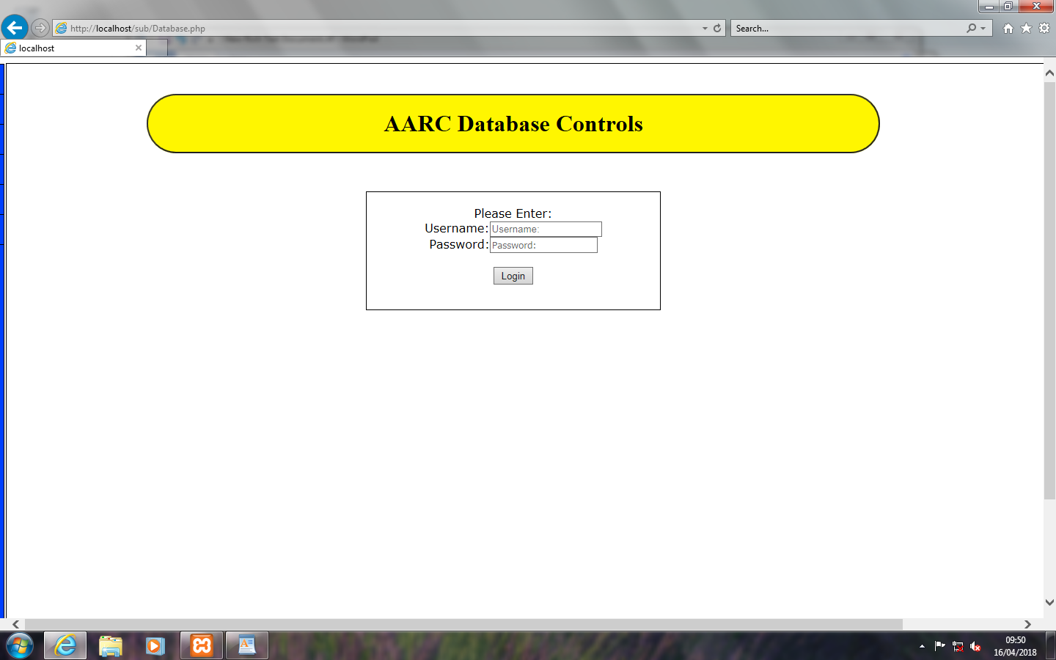

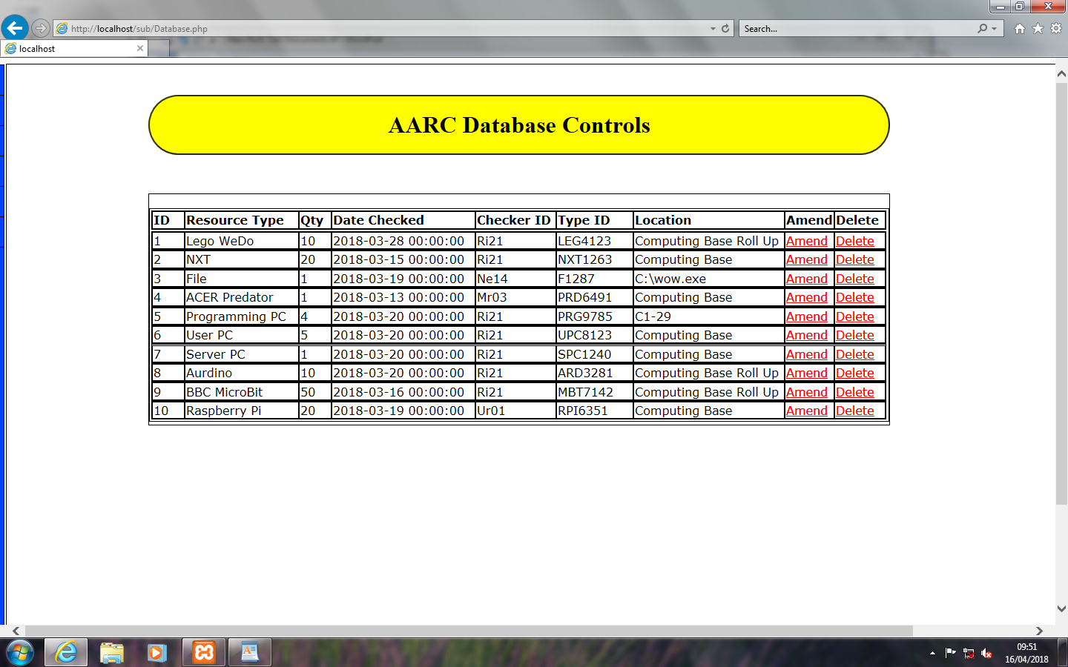

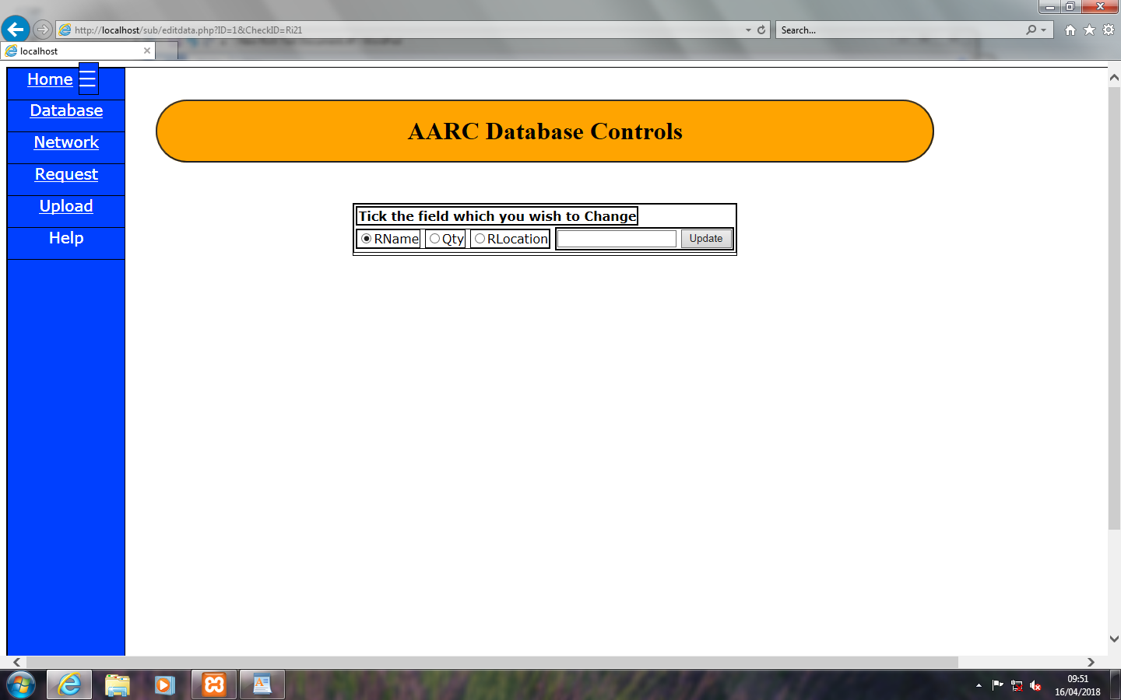

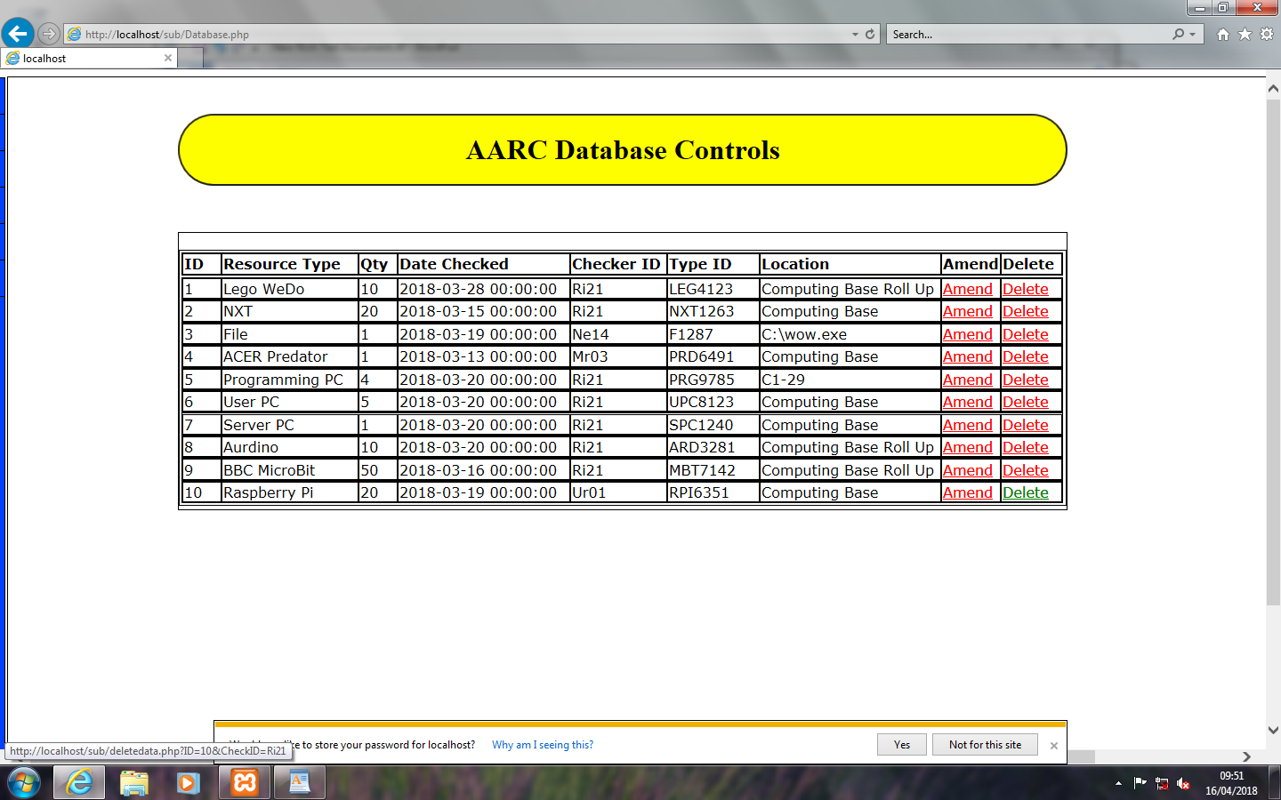

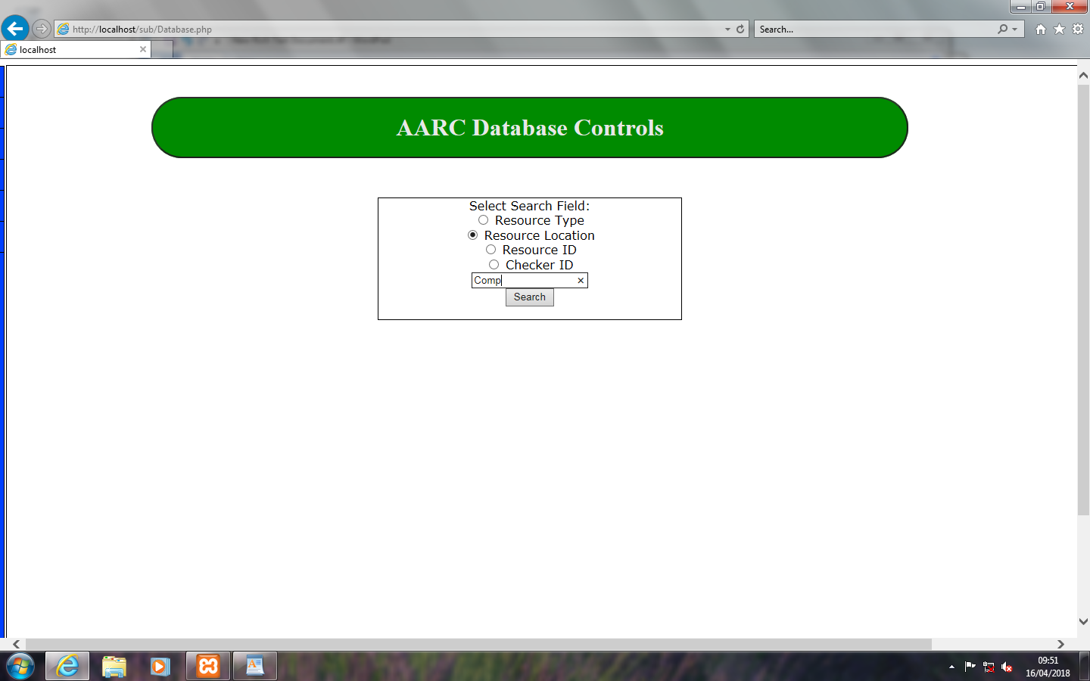

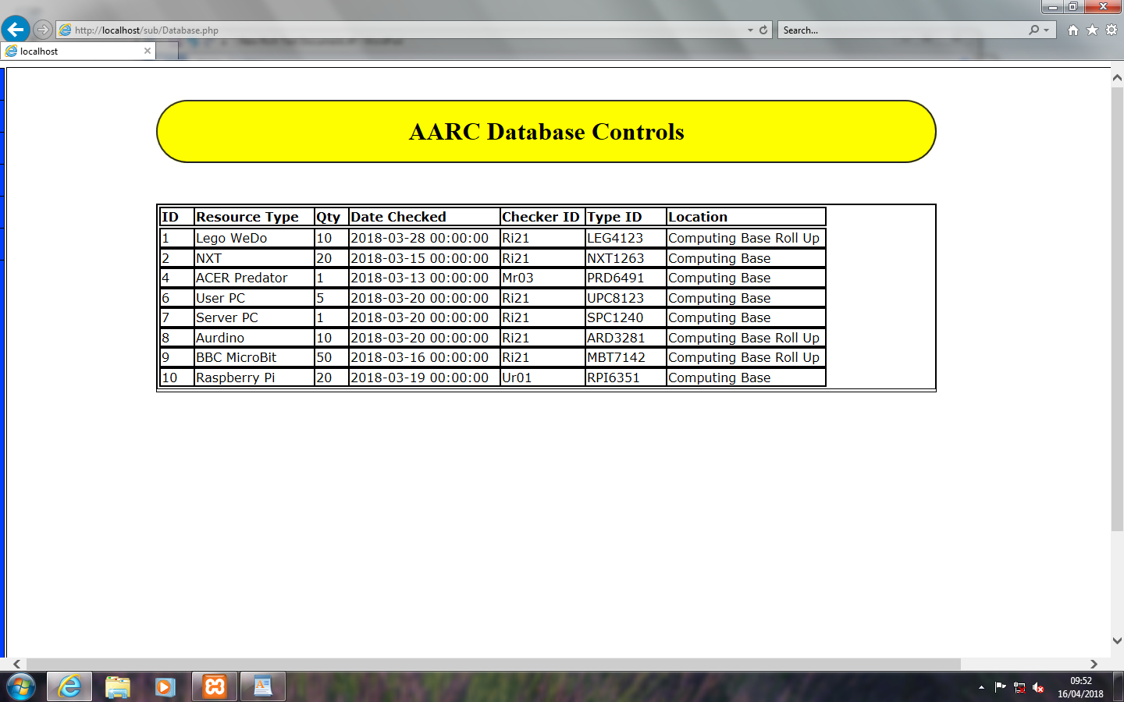

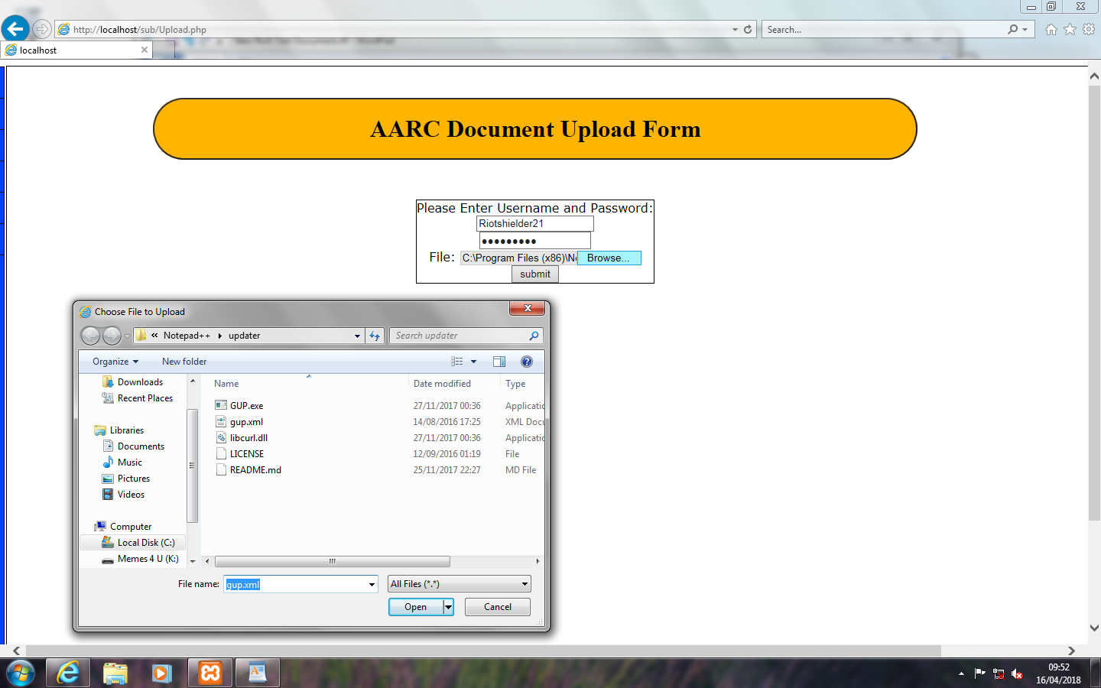

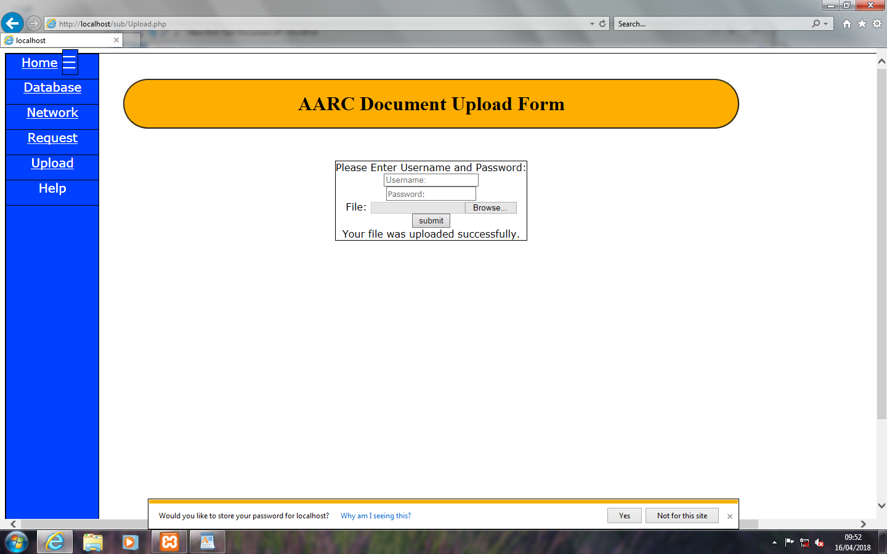

* MS ACCESS Details of Prebuilt Tables – These are not identical to MySQL but very Similar to final tables.

N:\Database3.accdb 19 March 2018

Table: CheckerT Page: 1

**Properties**

AlternateBackShade: 95 AlternateBackThemeColorI 1

AlternateBackTint: 100 BackShade: 100

BackTint: 100 DatasheetForeThemeColor 0

DatasheetGridlinesThemeC 3 DateCreated: 19/03/2018 10:48:18

DefaultView: 2 DisplayViewsOnSharePoint 1

FilterOnLoad: False GUID: {guid {95D8B313-3CDD-

4508-A81A-

HideNewField: False LastUpdated: 19/03/2018 11:19:06

NameMap: Long binary data OrderByOn: False

OrderByOnLoad: True Orientation: Left-to-Right

PublishToWeb: 1 ReadOnlyWhenDisconnecte False

RecordCount: 0 ThemeFontIndex: 1

TotalsRow: False Updatable: True

**Columns**

Name Type Size

CheckID Text 15

AggregateType: -1

AllowZeroLength: True

AppendOnly: False

Attributes: Variable Length

CollatingOrder: General

ColumnHidden: False

ColumnOrder: Default

ColumnWidth: Default

CurrencyLCID: 0

DataUpdatable: False

DisplayControl: Text Box

GUID: {guid {FC886265-8F0A-4F50-ADED-5FC74FEAF6B6}}

IMEMode: 0

IMESentenceMode: 3

OrdinalPosition: 0

Required: True

ResultType: 0

SourceField: CheckID

SourceTable: CheckerT

TextAlign: General

UnicodeCompression: False

UserID Long Integer 4

AggregateType: -1

AllowZeroLength: False

AppendOnly: False

Attributes: Fixed Size

CollatingOrder: General

ColumnHidden: False

ColumnOrder: Default

ColumnWidth: Default

CurrencyLCID: 0

DataUpdatable: False

DecimalPlaces: Auto

DisplayControl: Text Box

GUID: {guid {8F0F724C-5311-4275-AB48-91437BB528F4}}

OrdinalPosition: 1

N:\Database3.accdb 19 March 2018

Table: CheckerT Page: 2

Required: True

ResultType: 0

SourceField: UserID

SourceTable: CheckerT

TextAlign: General

**Relationships**

**CheckerTInventoryT**

**CheckerT** **InventoryT**

CheckID 1  CheckID

Attributes: Enforced

RelationshipType: One-To-Many

**UserTCheckerTs**

**UserT** **CheckerT**

UserID 1 1 UserID

Attributes: Unique, Enforced

RelationshipType: One-To-One

**Table Indexes**

Name Number of Fields

PrimaryKey 1

Clustered: False

DistinctCount: 0

Foreign: False

IgnoreNulls: False

Name: PrimaryKey

Primary: True

Required: True

Unique: True

Fields:

CheckID Ascending

UserID 1

Clustered: False

DistinctCount: 0

Foreign: False

IgnoreNulls: False

Name: UserID

Primary: False

Required: False

Unique: True

Fields:

UserID Ascending

UserTCheckerT 1

Clustered: False

DistinctCount: 0

Foreign: True

N:\Database3.accdb 19 March 2018

Table: CheckerT Page: 3

IgnoreNulls: False

Name: UserTCheckerT

Primary: False

Required: False

Unique: True

Fields:

UserID Ascending

**User Permissions**

admin Delete, Read Permissions, Set Permissions, Change Owner, Read Definition,

Write Definition, Read Data, Insert Data, Update Data, Delete Data

**Group Permissions**

Admins Delete, Read Permissions, Set Permissions, Change Owner, Read Definition,

Write Definition, Read Data, Insert Data, Update Data, Delete Data

Users Delete, Read Permissions, Set Permissions, Change Owner, Read Definition,

Write Definition, Read Data, Insert Data, Update Data, Delete Data

N:\Database3.accdb 19 March 2018

Table: CheckerT Page: 1

**Properties**

AlternateBackShade: 95 AlternateBackThemeColorI 1

AlternateBackTint: 100 BackShade: 100

BackTint: 100 DatasheetForeThemeColor 0

DatasheetGridlinesThemeC 3 DateCreated: 19/03/2018 10:48:18

DefaultView: 2 DisplayViewsOnSharePoint 1

FilterOnLoad: False GUID: {guid {95D8B313-3CDD-

4508-A81A-

HideNewField: False LastUpdated: 19/03/2018 11:19:06

NameMap: Long binary data OrderByOn: False

OrderByOnLoad: True Orientation: Left-to-Right

PublishToWeb: 1 ReadOnlyWhenDisconnecte False

RecordCount: 0 ThemeFontIndex: 1

TotalsRow: False Updatable: True

**Columns**

Name Type Size

CheckID Text 15

AggregateType: -1

AllowZeroLength: True

AppendOnly: False

Attributes: Variable Length

CollatingOrder: General

ColumnHidden: False

ColumnOrder: Default

ColumnWidth: Default

CurrencyLCID: 0

DataUpdatable: False

DisplayControl: Text Box

GUID: {guid {FC886265-8F0A-4F50-ADED-5FC74FEAF6B6}}

IMEMode: 0

IMESentenceMode: 3

OrdinalPosition: 0

Required: True

ResultType: 0

SourceField: CheckID

SourceTable: CheckerT

TextAlign: General

UnicodeCompression: False

UserID Long Integer 4

AggregateType: -1

AllowZeroLength: False

AppendOnly: False

Attributes: Fixed Size

CollatingOrder: General

ColumnHidden: False

ColumnOrder: Default

ColumnWidth: Default

CurrencyLCID: 0

DataUpdatable: False

DecimalPlaces: Auto

DisplayControl: Text Box

GUID: {guid {8F0F724C-5311-4275-AB48-91437BB528F4}}

OrdinalPosition: 1

N:\Database3.accdb 19 March 2018

Table: CheckerT Page: 2

Required: True

ResultType: 0

SourceField: UserID

SourceTable: CheckerT

TextAlign: General

**Relationships**

**CheckerTInventoryT**

**CheckerT** **InventoryT**

CheckID 1  CheckID

Attributes: Enforced

RelationshipType: One-To-Many

**UserTCheckerT**

**UserT** **CheckerT**

UserID 1 1 UserID

Attributes: Unique, Enforced

RelationshipType: One-To-One

**Table Indexes**

Name Number of Fields

PrimaryKey 1

Clustered: False

DistinctCount: 0

Foreign: False

IgnoreNulls: False

Name: PrimaryKey

Primary: True

Required: True

Unique: True

Fields:

CheckID Ascending

UserID 1

Clustered: False

DistinctCount: 0

Foreign: False

IgnoreNulls: False

Name: UserID

Primary: False

Required: False

Unique: True

Fields:

UserID Ascending

UserTCheckerT 1

Clustered: False

DistinctCount: 0

Foreign: True

N:\Database3.accdb 19 March 2018

Table: CheckerT Page: 3

IgnoreNulls: False

Name: UserTCheckerT

Primary: False

Required: False

Unique: True

Fields:

UserID Ascending

**User Permissions**

admin Delete, Read Permissions, Set Permissions, Change Owner, Read Definition,

Write Definition, Read Data, Insert Data, Update Data, Delete Data

**Group Permissions**

Admins Delete, Read Permissions, Set Permissions, Change Owner, Read Definition,

Write Definition, Read Data, Insert Data, Update Data, Delete Data

Users Delete, Read Permissions, Set Permissions, Change Owner, Read Definition,

Write Definition, Read Data, Insert Data, Update Data, Delete Data

N:\Database3.accdb 19 March 2018

Table: InventoryT Page: 4

**Properties**

AlternateBackShade: 95 AlternateBackThemeColorI 1

AlternateBackTint: 100 BackShade: 100

BackTint: 100 DatasheetForeThemeColor 0

DatasheetGridlinesThemeC 3 DateCreated: 19/03/2018 10:38:30

DefaultView: 2 DisplayViewsOnSharePoint 1

FilterOnLoad: False GUID: {guid {2C8869C7-38F7-

4CC1-80E2-21B23DD23CE5}}

HideNewField: False LastUpdated: 19/03/2018 11:45:45

NameMap: Long binary data OrderByOn: False

OrderByOnLoad: True Orientation: Left-to-Right

PublishToWeb: 1 ReadOnlyWhenDisconnecte False

RecordCount: 0 ThemeFontIndex: 1

TotalsRow: False Updatable: True

**Columns**

Name Type Size

ID Long Integer 4

AggregateType: -1

AllowZeroLength: False

AppendOnly: False

Attributes: Fixed Size, Auto-Increment

CollatingOrder: General

ColumnHidden: False

ColumnOrder: Default

ColumnWidth: Default

CurrencyLCID: 0

DataUpdatable: False

GUID: {guid {D71841D0-D082-486C-9462-D54D41C61603}}

OrdinalPosition: 0

Required: False

ResultType: 0

SourceField: ID

SourceTable: InventoryT

TextAlign: General

Qty Integer 2

AggregateType: -1

AllowZeroLength: False

AppendOnly: False

Attributes: Fixed Size

CollatingOrder: General

ColumnHidden: False

ColumnOrder: Default

ColumnWidth: Default

CurrencyLCID: 0

DataUpdatable: False

DecimalPlaces: Auto

DefaultValue: 1

DisplayControl: Text Box

GUID: {guid {26EC3282-1CE5-4432-A097-C10D1F331F07}}

OrdinalPosition: 1

Required: False

ResultType: 0

SourceField: Qty

N:\Database3.accdb 19 March 2018

Table: InventoryT Page: 5

SourceTable: InventoryT

TextAlign: General

DateChecked Date/Time 8

AggregateType: -1

AllowZeroLength: False

AppendOnly: False

Attributes: Fixed Size

CollatingOrder: General

ColumnHidden: False

ColumnOrder: Default

ColumnWidth: Default

CurrencyLCID: 0

DataUpdatable: False

Format: Short Date

GUID: {guid {D5FDC06F-AAF6-4F4A-B382-3B67A2D31722}}

IMEMode: 0

IMESentenceMode: 3

OrdinalPosition: 2

Required: True

ResultType: 0

ShowDatePicker: For dates

SourceField: DateChecked

SourceTable: InventoryT

TextAlign: General

CheckID Text 15

AggregateType: -1

AllowZeroLength: True

AppendOnly: False

Attributes: Variable Length

CollatingOrder: General

ColumnHidden: False

ColumnOrder: Default

ColumnWidth: Default

CurrencyLCID: 0

DataUpdatable: False

DisplayControl: Text Box

GUID: {guid {1893F57E-72A4-4C16-AAC3-14AEF60645BE}}

IMEMode: 0

IMESentenceMode: 3

OrdinalPosition: 3

Required: True

ResultType: 0

SourceField: CheckID

SourceTable: InventoryT

TextAlign: General

UnicodeCompression: True

TypeID Text 15

AggregateType: -1

AllowZeroLength: True

AppendOnly: False

Attributes: Variable Length

CollatingOrder: General

ColumnHidden: False

ColumnOrder: Default

ColumnWidth: Default

CurrencyLCID: 0

DataUpdatable: False

N:\Database3.accdb 19 March 2018

Table: InventoryT Page: 6

DisplayControl: Text Box

GUID: {guid {D7E6F7EB-A6AB-46E4-96DF-DBA5E130BA49}}

IMEMode: 0

IMESentenceMode: 3

OrdinalPosition: 4

Required: True

ResultType: 0

SourceField: TypeID

SourceTable: InventoryT

TextAlign: General

UnicodeCompression: True

**Relationships**

**CheckerTInventoryT**

**CheckerT** **InventoryT**

CheckID 1  CheckID

Attributes: Enforced

RelationshipType: One-To-Many

**ResourceTInventoryT**

**ResourceT** **InventoryT**

TypeID 1  TypeID

Attributes: Enforced

RelationshipType: One-To-Many

**Table Indexes**

Name Number of Fields

CheckerTInventoryT 1

Clustered: False

DistinctCount: 0

Foreign: True

IgnoreNulls: False

Name: CheckerTInventoryT

Primary: False

Required: False

Unique: False

Fields:

CheckID Ascending

CheckID 1

Clustered: False

DistinctCount: 0

Foreign: False

IgnoreNulls: False

Name: CheckID

Primary: False

Required: False

Unique: False

N:\Database3.accdb 19 March 2018

Table: InventoryT Page: 7

Fields:

CheckID Ascending

PrimaryKey 1

Clustered: False

DistinctCount: 0

Foreign: False

IgnoreNulls: False

Name: PrimaryKey

Primary: True

Required: True

Unique: True

Fields:

ID Ascending

ResourceTInventoryT 1

Clustered: False

DistinctCount: 0

Foreign: True

IgnoreNulls: False

Name: ResourceTInventoryT

Primary: False

Required: False

Unique: False

Fields:

TypeID Ascending

TypeID 1

Clustered: False

DistinctCount: 0

Foreign: False

IgnoreNulls: False

Name: TypeID

Primary: False

Required: False

Unique: False

Fields:

TypeID Ascending

**User Permissions**

admin Delete, Read Permissions, Set Permissions, Change Owner, Read Definition,

Write Definition, Read Data, Insert Data, Update Data, Delete Data

**Group Permissions**

Admins Delete, Read Permissions, Set Permissions, Change Owner, Read Definition,

Write Definition, Read Data, Insert Data, Update Data, Delete Data

Users Delete, Read Permissions, Set Permissions, Change Owner, Read Definition,

Write Definition, Read Data, Insert Data, Update Data, Delete Data

N:\Database3.accdb 19 March 2018

Table: ResourceT Page: 8

**Properties**

AlternateBackShade: 95 AlternateBackThemeColorI 1

AlternateBackTint: 100 BackShade: 100

BackTint: 100 DatasheetForeThemeColor 0

DatasheetGridlinesThemeC 3 DateCreated: 19/03/2018 10:36:02

DefaultView: 2 DisplayViewsOnSharePoint 1

FilterOnLoad: False GUID: {guid {05F3DB14-4F15-

4ED7-90B8-09FA20DE5C4A}}

HideNewField: False LastUpdated: 19/03/2018 11:07:19

NameMap: Long binary data OrderByOn: False

OrderByOnLoad: True Orientation: Left-to-Right

PublishToWeb: 1 ReadOnlyWhenDisconnecte False

RecordCount: 0 ThemeFontIndex: 1

TotalsRow: False Updatable: True

**Columns**

Name Type Size

TypeID Text 15

AggregateType: -1

AllowZeroLength: True

AppendOnly: False

Attributes: Variable Length

CollatingOrder: General

ColumnHidden: False

ColumnOrder: Default

ColumnWidth: Default

CurrencyLCID: 0

DataUpdatable: False

DisplayControl: Text Box

GUID: {guid {6763E0EB-2E5E-486E-A2F4-7FE833627F6F}}

IMEMode: 0

IMESentenceMode: 3

OrdinalPosition: 0

Required: True

ResultType: 0

SourceField: TypeID

SourceTable: ResourceT

TextAlign: General

UnicodeCompression: False

RName Text 30

AggregateType: -1

AllowZeroLength: True

AppendOnly: False

Attributes: Variable Length

CollatingOrder: General

ColumnHidden: False

ColumnOrder: Default

ColumnWidth: Default

CurrencyLCID: 0

DataUpdatable: False

DisplayControl: Text Box

GUID: {guid {54F49E36-C49B-4C0F-9340-AC3BDCD5BD6E}}

IMEMode: 0

IMESentenceMode: 3

N:\Database3.accdb 19 March 2018

Table: ResourceT Page: 9

OrdinalPosition: 1

Required: True

ResultType: 0

SourceField: RName

SourceTable: ResourceT

TextAlign: General

UnicodeCompression: True

RLocation Text 255

AggregateType: -1

AllowZeroLength: True

AppendOnly: False

Attributes: Variable Length

CollatingOrder: General

ColumnHidden: False

ColumnOrder: Default

ColumnWidth: Default

CurrencyLCID: 0

DataUpdatable: False

DisplayControl: Text Box

GUID: {guid {9911E964-8ECE-434C-B658-0CB2B2376C79}}

IMEMode: 0

IMESentenceMode: 3

OrdinalPosition: 2

Required: True

ResultType: 0

SourceField: RLocation

SourceTable: ResourceT

TextAlign: General

UnicodeCompression: True

FileType Text 8

AggregateType: -1

AllowZeroLength: True

AppendOnly: False

Attributes: Variable Length

CollatingOrder: General

ColumnHidden: False

ColumnOrder: Default

ColumnWidth: Default

CurrencyLCID: 0

DataUpdatable: False

DisplayControl: Text Box

GUID: {guid {CC190700-05F4-4E14-84CF-9AB632C42B54}}

IMEMode: 0

IMESentenceMode: 3

OrdinalPosition: 3

Required: False

ResultType: 0

SourceField: FileType

SourceTable: ResourceT

TextAlign: General

UnicodeCompression: True

FileSize Long Integer 4

AggregateType: -1

AllowZeroLength: False

AppendOnly: False

Attributes: Fixed Size

CollatingOrder: General

N:\Database3.accdb 19 March 2018

Table: ResourceT Page: 10

ColumnHidden: False

ColumnOrder: Default

ColumnWidth: Default

CurrencyLCID: 0

DataUpdatable: False

DecimalPlaces: Auto

DisplayControl: Text Box

GUID: {guid {27CFDA5A-A721-47C4-8645-BE7F38004B6E}}

OrdinalPosition: 4

Required: False

ResultType: 0

SourceField: FileSize

SourceTable: ResourceT

TextAlign: General

**Relationships**

**ResourceTInventoryT**

**ResourceT** **InventoryT**

TypeID 1  TypeID

Attributes: Enforced

RelationshipType: One-To-Many

**Table Indexes**

Name Number of Fields

PrimaryKey 1

Clustered: False

DistinctCount: 0

Foreign: False

IgnoreNulls: False

Name: PrimaryKey

Primary: True

Required: True

Unique: True

Fields:

TypeID Ascending

**User Permissions**

admin Delete, Read Permissions, Set Permissions, Change Owner, Read Definition,

Write Definition, Read Data, Insert Data, Update Data, Delete Data

**Group Permissions**

Admins Delete, Read Permissions, Set Permissions, Change Owner, Read Definition,

Write Definition, Read Data, Insert Data, Update Data, Delete Data

Users Delete, Read Permissions, Set Permissions, Change Owner, Read Definition,

Write Definition, Read Data, Insert Data, Update Data, Delete Data

N:\Database3.accdb 19 March 2018

Table: UserT Page: 11

**Properties**

AlternateBackShade: 95 AlternateBackThemeColorI 1

AlternateBackTint: 100 BackShade: 100

BackTint: 100 DatasheetForeThemeColor 0

DatasheetGridlinesThemeC 3 DateCreated: 19/03/2018 11:02:37

DefaultView: 2 DisplayViewsOnSharePoint 1

FilterOnLoad: False GUID: {guid {503FD671-1207-42F1-

A523-446EF7F79518}}

HideNewField: False LastUpdated: 19/03/2018 11:45:47

NameMap: Long binary data OrderByOn: False

OrderByOnLoad: True Orientation: Left-to-Right

PublishToWeb: 1 ReadOnlyWhenDisconnecte False

RecordCount: 0 ThemeFontIndex: 1

TotalsRow: False Updatable: True

**Columns**

Name Type Size

UserID Long Integer 4

AggregateType: -1

AllowZeroLength: False

AppendOnly: False

Attributes: Fixed Size, Auto-Increment

CollatingOrder: General

ColumnHidden: False

ColumnOrder: Default

ColumnWidth: Default

CurrencyLCID: 0

DataUpdatable: False

GUID: {guid {4054CFF1-0402-4D74-9675-D7189303BE61}}

OrdinalPosition: 0

Required: False

ResultType: 0

SourceField: UserID

SourceTable: UserT

TextAlign: General

MemberName Text 30

AggregateType: -1

AllowZeroLength: True

AppendOnly: False

Attributes: Variable Length

CollatingOrder: General

ColumnHidden: False

ColumnOrder: Default

ColumnWidth: Default

CurrencyLCID: 0

DataUpdatable: False

DisplayControl: Text Box

GUID: {guid {1A2178BE-01D1-412F-9035-8FFE81C85379}}

IMEMode: 0

IMESentenceMode: 3

OrdinalPosition: 1

Required: True

ResultType: 0

SourceField: MemberName

N:\Database3.accdb 19 March 2018

Table: UserT Page: 12

SourceTable: UserT

TextAlign: General

UnicodeCompression: True

Username Text 30

AggregateType: -1

AllowZeroLength: True

AppendOnly: False

Attributes: Variable Length

CollatingOrder: General

ColumnHidden: False

ColumnOrder: Default

ColumnWidth: Default

CurrencyLCID: 0

DataUpdatable: False

DisplayControl: Text Box

GUID: {guid {D657151C-8114-474D-8297-6595AD2EB721}}

IMEMode: 0

IMESentenceMode: 3

OrdinalPosition: 2

Required: True

ResultType: 0

SourceField: Username

SourceTable: UserT

TextAlign: General

UnicodeCompression: True

Password Text 30

AggregateType: -1

AllowZeroLength: True

AppendOnly: False

Attributes: Variable Length

CollatingOrder: General

ColumnHidden: False

ColumnOrder: Default

ColumnWidth: Default

CurrencyLCID: 0

DataUpdatable: False

DefaultValue: "Password1"

DisplayControl: Text Box

GUID: {guid {DA084A51-BC67-44A2-9C50-917318ECA378}}

IMEMode: 0

IMESentenceMode: 3

InputMask: \*

OrdinalPosition: 3

Required: True

ResultType: 0

SourceField: Password

SourceTable: UserT

TextAlign: General

UnicodeCompression: True

Privilege Yes/No 1

AggregateType: -1

AllowZeroLength: False

AppendOnly: False

Attributes: Fixed Size

CollatingOrder: General

ColumnHidden: False

ColumnOrder: Default

N:\Database3.accdb 19 March 2018

Table: UserT Page: 13

ColumnWidth: Default

CurrencyLCID: 0

DataUpdatable: False

DefaultValue: 0

DisplayControl: 106

Format: Yes/No

GUID: {guid {29F72F36-C53C-4E9C-89E8-7DF1F48760FD}}

OrdinalPosition: 4

Required: False

ResultType: 0

SourceField: Privilege

SourceTable: UserT

TextAlign: General

**Relationships**

**UserTCheckerT**

**UserT** **CheckerT**

UserID 1 1 UserID

Attributes: Unique, Enforced

RelationshipType: One-To-One

**Table Indexes**

Name Number of Fields

PrimaryKey 1

Clustered: False

DistinctCount: 0

Foreign: False

IgnoreNulls: False

Name: PrimaryKey

Primary: True

Required: True

Unique: True

Fields:

UserID Ascending

**User Permissions**

admin Delete, Read Permissions, Set Permissions, Change Owner, Read Definition,

Write Definition, Read Data, Insert Data, Update Data, Delete Data

**Group Permissions**

Admins Delete, Read Permissions, Set Permissions, Change Owner, Read Definition,

Write Definition, Read Data, Insert Data, Update Data, Delete Data

Users Delete, Read Permissions, Set Permissions, Change Owner, Read Definition,

Write Definition, Read Data, Insert Data, Update Data, Delete Data

N:\Database3.accdb 19 March 2018

Table: ResourceT Page: 8

**Properties**

AlternateBackShade: 95 AlternateBackThemeColorI 1

AlternateBackTint: 100 BackShade: 100

BackTint: 100 DatasheetForeThemeColor 0

DatasheetGridlinesThemeC 3 DateCreated: 19/03/2018 10:36:02

DefaultView: 2 DisplayViewsOnSharePoint 1

FilterOnLoad: False GUID: {guid {05F3DB14-4F15-

4ED7-90B8-09FA20DE5C4A}}

HideNewField: False LastUpdated: 19/03/2018 11:07:19

NameMap: Long binary data OrderByOn: False

OrderByOnLoad: True Orientation: Left-to-Right

PublishToWeb: 1 ReadOnlyWhenDisconnecte False

RecordCount: 0 ThemeFontIndex: 1

TotalsRow: False Updatable: True

**Columns**

Name Type Size

TypeID Text 15

AggregateType: -1

AllowZeroLength: True

AppendOnly: False

Attributes: Variable Length

CollatingOrder: General

ColumnHidden: False

ColumnOrder: Default

ColumnWidth: Default

CurrencyLCID: 0

DataUpdatable: False

DisplayControl: Text Box

GUID: {guid {6763E0EB-2E5E-486E-A2F4-7FE833627F6F}}

IMEMode: 0

IMESentenceMode: 3

OrdinalPosition: 0

Required: True

ResultType: 0

SourceField: TypeID

SourceTable: ResourceT

TextAlign: General

UnicodeCompression: False

RName Text 30

AggregateType: -1

AllowZeroLength: True

AppendOnly: False

Attributes: Variable Length

CollatingOrder: General

ColumnHidden: False

ColumnOrder: Default

ColumnWidth: Default

CurrencyLCID: 0

DataUpdatable: False

DisplayControl: Text Box

GUID: {guid {54F49E36-C49B-4C0F-9340-AC3BDCD5BD6E}}

IMEMode: 0

IMESentenceMode: 3

N:\Database3.accdb 19 March 2018

Table: ResourceT Page: 9

OrdinalPosition: 1

Required: True

ResultType: 0

SourceField: RName

SourceTable: ResourceT

TextAlign: General

UnicodeCompression: True

RLocation Text 255

AggregateType: -1

AllowZeroLength: True

AppendOnly: False

Attributes: Variable Length

CollatingOrder: General

ColumnHidden: False

ColumnOrder: Default

ColumnWidth: Default

CurrencyLCID: 0

DataUpdatable: False

DisplayControl: Text Box

GUID: {guid {9911E964-8ECE-434C-B658-0CB2B2376C79}}

IMEMode: 0

IMESentenceMode: 3

OrdinalPosition: 2

Required: True

ResultType: 0

SourceField: RLocation

SourceTable: ResourceT

TextAlign: General

UnicodeCompression: True

FileType Text 8

AggregateType: -1

AllowZeroLength: True

AppendOnly: False

Attributes: Variable Length

CollatingOrder: General

ColumnHidden: False

ColumnOrder: Default

ColumnWidth: Default

CurrencyLCID: 0

DataUpdatable: False

DisplayControl: Text Box

GUID: {guid {CC190700-05F4-4E14-84CF-9AB632C42B54}}

IMEMode: 0

IMESentenceMode: 3

OrdinalPosition: 3

Required: False

ResultType: 0

SourceField: FileType

SourceTable: ResourceT

TextAlign: General

UnicodeCompression: True

FileSize Long Integer 4

AggregateType: -1

AllowZeroLength: False

AppendOnly: False

Attributes: Fixed Size

CollatingOrder: General

N:\Database3.accdb 19 March 2018

Table: ResourceT Page: 10

ColumnHidden: False

ColumnOrder: Default

ColumnWidth: Default

CurrencyLCID: 0

DataUpdatable: False

DecimalPlaces: Auto

DisplayControl: Text Box

GUID: {guid {27CFDA5A-A721-47C4-8645-BE7F38004B6E}}

OrdinalPosition: 4

Required: False

ResultType: 0

SourceField: FileSize

SourceTable: ResourceT

TextAlign: General

**Relationships**

**ResourceTInventoryT**

**ResourceT** **InventoryT**

TypeID 1  TypeID

Attributes: Enforced

RelationshipType: One-To-Many

**Table Indexes**

Name Number of Fields

PrimaryKey 1

Clustered: False

DistinctCount: 0

Foreign: False

IgnoreNulls: False

Name: PrimaryKey

Primary: True

Required: True

Unique: True

Fields:

TypeID Ascending

**User Permissions**

admin Delete, Read Permissions, Set Permissions, Change Owner, Read Definition,

Write Definition, Read Data, Insert Data, Update Data, Delete Data

**Group Permissions**

Admins Delete, Read Permissions, Set Permissions, Change Owner, Read Definition,

Write Definition, Read Data, Insert Data, Update Data, Delete Data

Users Delete, Read Permissions, Set Permissions, Change Owner, Read Definition,

Write Definition, Read Data, Insert Data, Update Data, Delete Data

N:\Database3.accdb 19 March 2018

Table: UserT Page: 11

**Properties**

AlternateBackShade: 95 AlternateBackThemeColorI 1

AlternateBackTint: 100 BackShade: 100

BackTint: 100 DatasheetForeThemeColor 0

DatasheetGridlinesThemeC 3 DateCreated: 19/03/2018 11:02:37

DefaultView: 2 DisplayViewsOnSharePoint 1

FilterOnLoad: False GUID: {guid {503FD671-1207-42F1-

A523-446EF7F79518}}

HideNewField: False LastUpdated: 19/03/2018 11:45:47

NameMap: Long binary data OrderByOn: False

OrderByOnLoad: True Orientation: Left-to-Right

PublishToWeb: 1 ReadOnlyWhenDisconnecte False

RecordCount: 0 ThemeFontIndex: 1

TotalsRow: False Updatable: True

**Columns**

Name Type Size

UserID Long Integer 4

AggregateType: -1

AllowZeroLength: False

AppendOnly: False

Attributes: Fixed Size, Auto-Increment

CollatingOrder: General

ColumnHidden: False

ColumnOrder: Default

ColumnWidth: Default

CurrencyLCID: 0

DataUpdatable: False

GUID: {guid {4054CFF1-0402-4D74-9675-D7189303BE61}}

OrdinalPosition: 0

Required: False

ResultType: 0

SourceField: UserID

SourceTable: UserT

TextAlign: General

MemberName Text 30

AggregateType: -1

AllowZeroLength: True

AppendOnly: False

Attributes: Variable Length

CollatingOrder: General

ColumnHidden: False

ColumnOrder: Default

ColumnWidth: Default

CurrencyLCID: 0

DataUpdatable: False

DisplayControl: Text Box

GUID: {guid {1A2178BE-01D1-412F-9035-8FFE81C85379}}

IMEMode: 0

IMESentenceMode: 3

OrdinalPosition: 1

Required: True

ResultType: 0

SourceField: MemberName

N:\Database3.accdb 19 March 2018

Table: UserT Page: 12

SourceTable: UserT

TextAlign: General

UnicodeCompression: True

Username Text 30

AggregateType: -1

AllowZeroLength: True

AppendOnly: False

Attributes: Variable Length

CollatingOrder: General

ColumnHidden: False

ColumnOrder: Default

ColumnWidth: Default

CurrencyLCID: 0

DataUpdatable: False

DisplayControl: Text Box

GUID: {guid {D657151C-8114-474D-8297-6595AD2EB721}}

IMEMode: 0

IMESentenceMode: 3

OrdinalPosition: 2

Required: True

ResultType: 0

SourceField: Username

SourceTable: UserT

TextAlign: General

UnicodeCompression: True

Password Text 30

AggregateType: -1

AllowZeroLength: True

AppendOnly: False

Attributes: Variable Length

CollatingOrder: General

ColumnHidden: False

ColumnOrder: Default

ColumnWidth: Default

CurrencyLCID: 0

DataUpdatable: False

DefaultValue: "Password1"

DisplayControl: Text Box

GUID: {guid {DA084A51-BC67-44A2-9C50-917318ECA378}}

IMEMode: 0

IMESentenceMode: 3

InputMask: \*

OrdinalPosition: 3

Required: True

ResultType: 0

SourceField: Password

SourceTable: UserT

TextAlign: General

UnicodeCompression: True

Privilege Yes/No 1

AggregateType: -1

AllowZeroLength: False

AppendOnly: False

Attributes: Fixed Size

CollatingOrder: General

ColumnHidden: False

ColumnOrder: Default

N:\Database3.accdb 19 March 2018

Table: UserT Page: 13

ColumnWidth: Default

CurrencyLCID: 0

DataUpdatable: False

DefaultValue: 0

DisplayControl: 106

Format: Yes/No

GUID: {guid {29F72F36-C53C-4E9C-89E8-7DF1F48760FD}}

OrdinalPosition: 4

Required: False

ResultType: 0

SourceField: Privilege

SourceTable: UserT

TextAlign: General

**Relationships**

**UserTCheckerT**

**UserT** **CheckerT**

UserID 1 1 UserID

Attributes: Unique, Enforced

RelationshipType: One-To-One

**Table Indexes**

Name Number of Fields

PrimaryKey 1

Clustered: False

DistinctCount: 0

Foreign: False

IgnoreNulls: False

Name: PrimaryKey

Primary: True

Required: True

Unique: True

Fields:

UserID Ascending

**User Permissions**

admin Delete, Read Permissions, Set Permissions, Change Owner, Read Definition,

Write Definition, Read Data, Insert Data, Update Data, Delete Data

**Group Permissions**

Admins Delete, Read Permissions, Set Permissions, Change Owner, Read Definition,

Write Definition, Read Data, Insert Data, Update Data, Delete Data

Users Delete, Read Permissions, Set Permissions, Change Owner, Read Definition,

Write Definition, Read Data, Insert Data, Update Data, Delete Data

# Alpha Testing and Debugging

### Test Table and Results

Red Text – Solutions to be sorted during the beta test phase

|  |  |  |  |  |  |
| --- | --- | --- | --- | --- | --- |
| **Area** | **Object** | **Test Type** | **Data** | **Pass?** | **Notes** |
| **UI Elements** | Nav Bar | Visual - Functional | Mouse - Hover | Pass | ‘Pop out part could have a bit that sticks out so its clearer |
| Images | Visual – Functional | Page Load | Pass | ‘images add a little depth to the page |
| Title Block | Visual – Functional | Page Load | Pass | ‘colour tries to make the page less bland |
| Internal Links (in Nav Bar) | Visual – Functional | Mouse - Click | Pass |  |
| Database Page Login Form Displays | Visual – Functional | Page Load | Pass | ‘added a new button |
| Database Admin Table | Visual – Functional | Page Update | Pass |  |
| Database Search Form | Visual – Functional | Page Update | Pass |  |
| Database Query Table | Visual – Functional | Page Update | Pass |  |
| Amend Link | Visual – Functional | Mouse - Click | Pass |  |
| Delete Link | Visual – Functional | Mouse – Click | Pass |  |
| Insert Stock Link | Visual – Functional | Mouse – Click | Pass |  |
| Upload Form | Visual – Functional | Page Load | Pass |  |
| Upload Error Feedback | Visual – Functional | Page Update | Pass |  |
| Upload Success Feedback | Visual – Functional | Page Update | Pass |  |
| Request Text Area | Visual – Functional | Page Load | Fail | ‘Having Parse errors and File Issues |
| Request Pass Feedback | Visual – Functional | Page Update | Fail | ‘Having Parse as well as file issues – to be fixed in beta |
| Request Fail Feedback | Visual – Functional | Page Update | Fail | ‘Corrections to Request Features have been made during a Beta test |
| Amend Form | Visual – Functional | Page Load | Pass |  |
| Amend Success Feedback | Visual – Functional | Page Update | Pass |  |
| Amend Fail Feedback | Visual – Functional | Page Update | Pass |  |
| Delete Success Feedback | Visual – Non-Functional | Page Update | Pass |  |
| Delete Fail Feedback | Visual – Non-Functional | Page Update | Pass |  |
| Insert Stock Form | Visual – Functional | Page Load | Pass |  |
| Insert-Stock Pass Feedback | Visual – Non-Functional | Page Update | Pass |  |
| Insert Stock Fail Feedback | Visual – Non-Functional | Page Update | Pass |  |
| Network Page Update Ready | Visual –Functional | N/A | Pass |  |
| **PHP Processes** | Dynamic Table Update | Data Dependant | Form Submission | Pass |  |
| Dynamic Table Search Update | Data Dependant | Form Submission | Pass |  |
| Delete Link Code | Normal | Field ‘ID’ for Record | Pass |  |
| Amend Form Rname | Normal |  | Fail | ‘the amend forms are all taking values except a data retention issue which needs to be solved. (form isn’t submitting existing data a second time to avoid it being lost when the server calls itself and new data is passed via the post method) |
| Amend Form  Rname | Extreme |  | Pass | ‘otherwise, data is processed correctly |
| Amend Form Rname | Exceptional |  | Pass | ‘and is passed to the SQL correctly |
| Amend Form RLocation | Normal | ‘Computing’ | Pass | ‘it’s also validated and filtered |
| Amend Form RLocation | Extreme | ‘Computing Roll Up’ | Pass | ‘this isn’t failing |
| Amend Form RLocation | Exceptional | ‘Computing Research Area’ | Pass | ‘char limit exceeded’ |
| Amend Form RQty | Normal | 12 | Pass |  |
| Amend Form RQty | Extreme | 0 | Pass |  |
| Amend Form RQty | Exceptional | NULL | Pass |  |
| Amend Form RQty | Exceptional | Sd6g5 | Pass |  |
| Insert Stock Form Rname | Normal | ‘NXT’ | Pass | ‘insert stock forms are experiencing a similar issue with data retention and needs a solution out with using the PHP self-method which is posting data |
| Insert Stock Form Rname | Exceptional | NULL | Pass | ‘otherwise, data is processed correctly |
| Insert Stock Form RLocation | Normal | ‘Computing’ | Pass | ‘and is passed to the SQL correctly |
| Insert Stock Form RLocation | Extreme | ‘Computing Roll Up’ | Pass | ‘it’s also validated and filtered |
| Insert Stock Form RLocation | Exceptional | ‘Computing Research Area’ | Pass | ‘this isn’t failing |
| Insert Stock Form RQty | Normal | 6 | Pass |  |
| Insert Stock Form RQty | Extreme | 0 | Pass |  |
| Insert Stock Form RQty | Exceptional | NULL | Pass |  |
| Insert Stock Form RQty | Exceptional | ‘Fg5’ | Pass |  |
| Upload Form Username | Normal | ‘jeff3’ | Pass |  |
| Upload Form Username | Exceptional | NULL | Pass |  |
| Upload Form Password | Normal | ‘Password1’ | Pass |  |
| Upload Form Password | Exceptional | NULL | Pass |  |
| Upload Form File | Normal | ‘real file’ | Pass |  |
| Upload Form File | Extreme | ‘Very large file’ | Pass |  |
| Upload Form File | Exceptional | ‘no file’ | Pass |  |
| Request Form Username | Normal | ‘jeff3’ | Pass |  |
| Request Form Username | Exceptional | NULL | Pass |  |
| Request Form Title | Normal | ‘Broken webpage’ | Pass |  |
| Request Form Title | Exceptional | NULL | Pass |  |
| Request Form Report | Normal | ‘paragraph about webpage’ | Pass |  |
| Request Form Report | Exceptional | NULL | Pass |  |
| Request Form File Create | Normal | ‘file name’ | Fail | ‘Same file issue that cause the page to crash, parse error on unexpected eof |
| Request Form File Write | Normal | ‘file contents’ | Fail | ‘needs the file creation and write methods revised |
| Request Form File Close | Normal | ‘filename’ | Fail | ‘investigate as to why its unexpected end of file |
| Database Login Username | Normal | ‘jeff3’ | Pass |  |
| Database Login Username | Extreme | ‘invalid username’ | Pass |  |
| Database Login Username | Exceptional | NULL | Pass |  |
| Database Login Password | Normal | ‘Password1’ | Pass |  |
| Database Login Password | Extreme | ‘invalid Password’ | Pass |  |
| Database Login Password | Exceptional | NULL | Pass |  |
| **SQL Queries** | Database Query Name | Normal | ‘NXT’ | Pass |  |
| Database Query Name | Exceptional | NULL | Pass |  |
| Database Query Location | Normal | ‘Comp’ | Pass |  |
| Database Query Location | Extreme | 0 | Pass |  |
| Database Query Location | Exceptional | NULL | Pass |  |
| Database Query  TypeID | Normal | ‘F2187’ | Pass |  |
| Database Query TypeID | Extreme | NULL | Pass |  |
| Database Query CheckerID | Normal | Ri21 | Pass |  |
| Database Query CheckerID | Extreme | ‘Nev2’ | Pass |  |
| Database Query CheckerID | Exceptional | Null | Pass |  |
| Amend Page Rname | Normal | ‘NXT’ | Pass |  |
| Amend Page  Rname | Extreme | ‘0’ | Pass |  |
| Amend Page Rname | Exceptional | NULL | Pass | ‘Writes a blank value’ |
| Amend Page RLocation | Normal | ‘Computing’ | Pass |  |
| Amend Page RLocation | Extreme | ‘Computing base roll up’ | Pass | ‘char limit’ |
| Amend Page RLocation | Exceptional | NULL | Pass |  |
| Amend Page RQty | Normal | ‘6’ | Pass |  |
| Amend Page RQty | Extreme | ‘0’ | Pass |  |
| Amend Page RQty | Exceptional | Null | Pass |  |
| Amend Page RQty | Exceptional | ‘85641.82140’ | Pass | ‘SQL take the int Value for the particular decimal’ |
| Insert Stock Page Rname | Normal | ‘NXT’ | Pass |  |
| Insert Stock Page Rname | Extreme | ‘0’ | Pass |  |
| Insert Stock Page Rname | Exceptional | NULL | Pass |  |
| Insert Stock Page RLocation | Normal | ‘Computing’ | Pass |  |
| Insert Stock Page RLocation | Extreme | ‘Computing base roll up’ | Pass |  |
| Insert Stock Page RLocation | Exceptional | NULL | Pass |  |
| Insert Stock Page RQty | Normal | ‘6’ | Pass |  |
| Insert Stock Page RQty | Extreme | ‘0’ | Pass |  |
| Insert Stock Page RQty | Exceptional | Null | Pass |  |
| Insert Stock Page RQty | Exceptional | ‘0.3 | Pass | ‘SQL take the int Value’ |
| Upload Form Username | Normal | ‘jeff3’ | Pass | ‘SQL Queries return literal values for |
| Upload Form Username | Extreme | ‘invalid username’ | Pass | What is passed and in no case are any of |
| Upload Form Username | Exceptional | NULL | Pass | The passed value being interpreted |
| Upload Form Password | Normal | ‘Password1’ | Pass | As false or invalid’ |
| Upload Form Password | Extreme | ‘invalid Password’ | Pass |  |
| Upload Form Password | Exceptional | NULL | Pass |  |
| Upload Form File | Normal | ‘real file’ | Pass |  |
| Upload Form File Details | Normal | ‘real file’s details from PHP’ | Pass |  |
| Upload Form File Upload | Normal | ‘real file’s details from PHP’ | Pass |  |
| Upload Form File | Extreme | ‘Very Large File’ | Pass |  |
| Upload Form File Details | Extreme | ‘file’s details from PHP’ | Pass |  |
|  | Upload Form File Upload | Extreme | ‘file’s details from PHP’ | Pass |  |
|  | Upload Form File | Exceptional | ‘no File’ | Pass |  |
|  | Upload Form File Details | Exceptional | ‘SQL doesn’t get executed’ | Pass |  |
|  | Upload Form File Upload | Exceptional | ‘SQL doesn’t get executed’ | Pass |  |

# Beta Testing and Debugging

User Beta Test Forms shown below detail what works and doesn’t so that further debugging can be carried out.

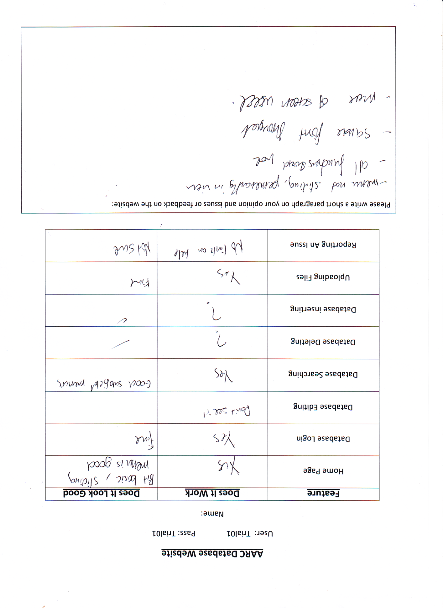

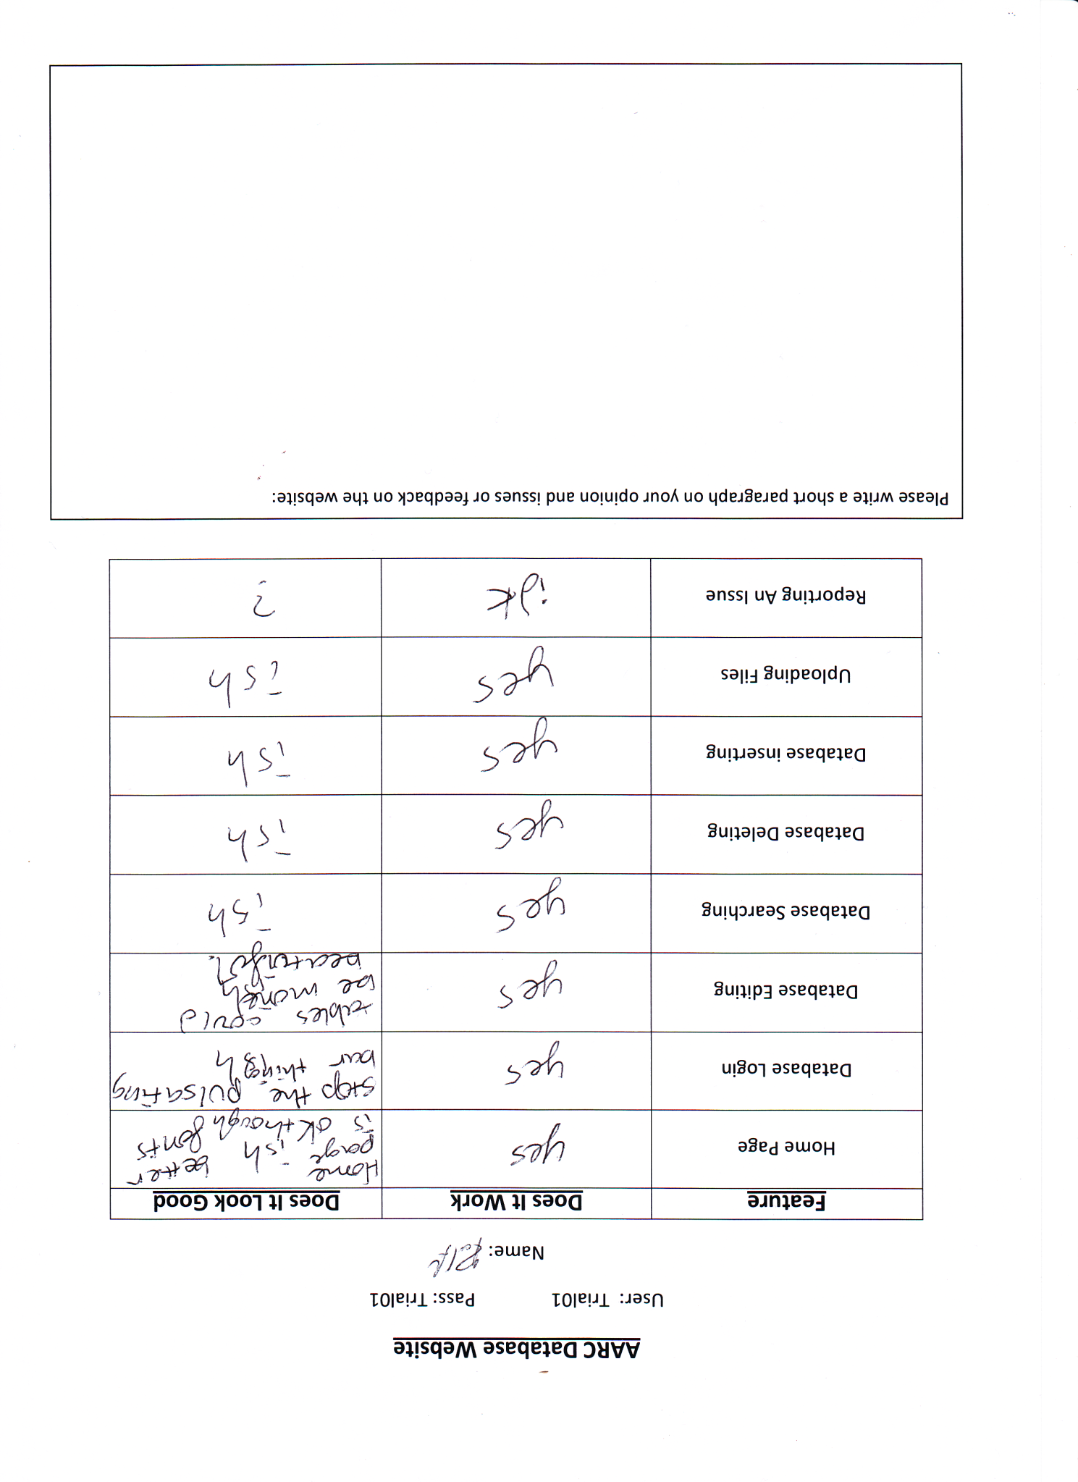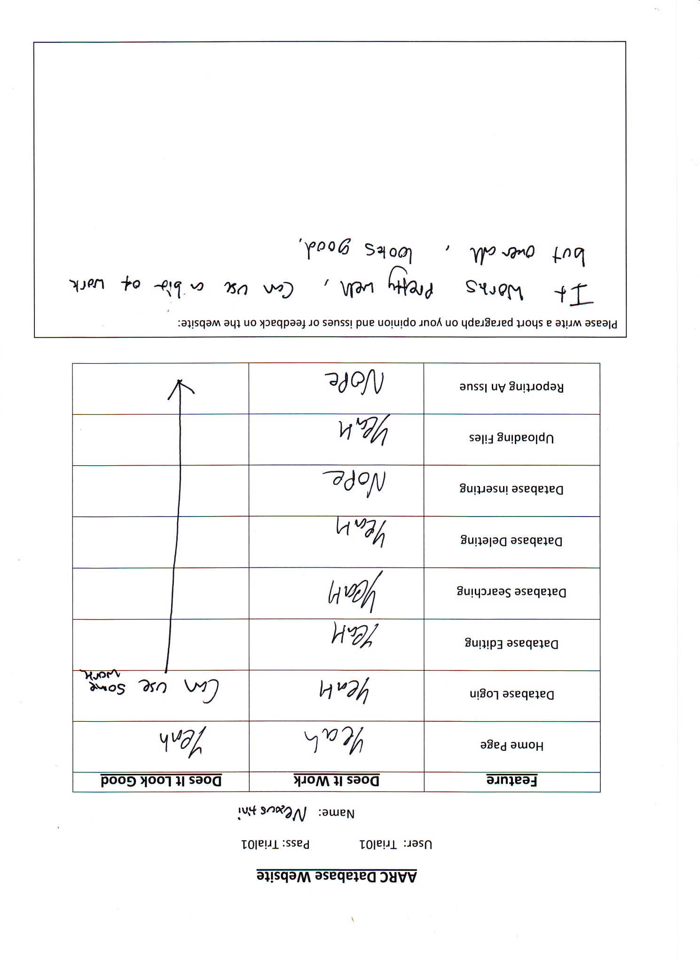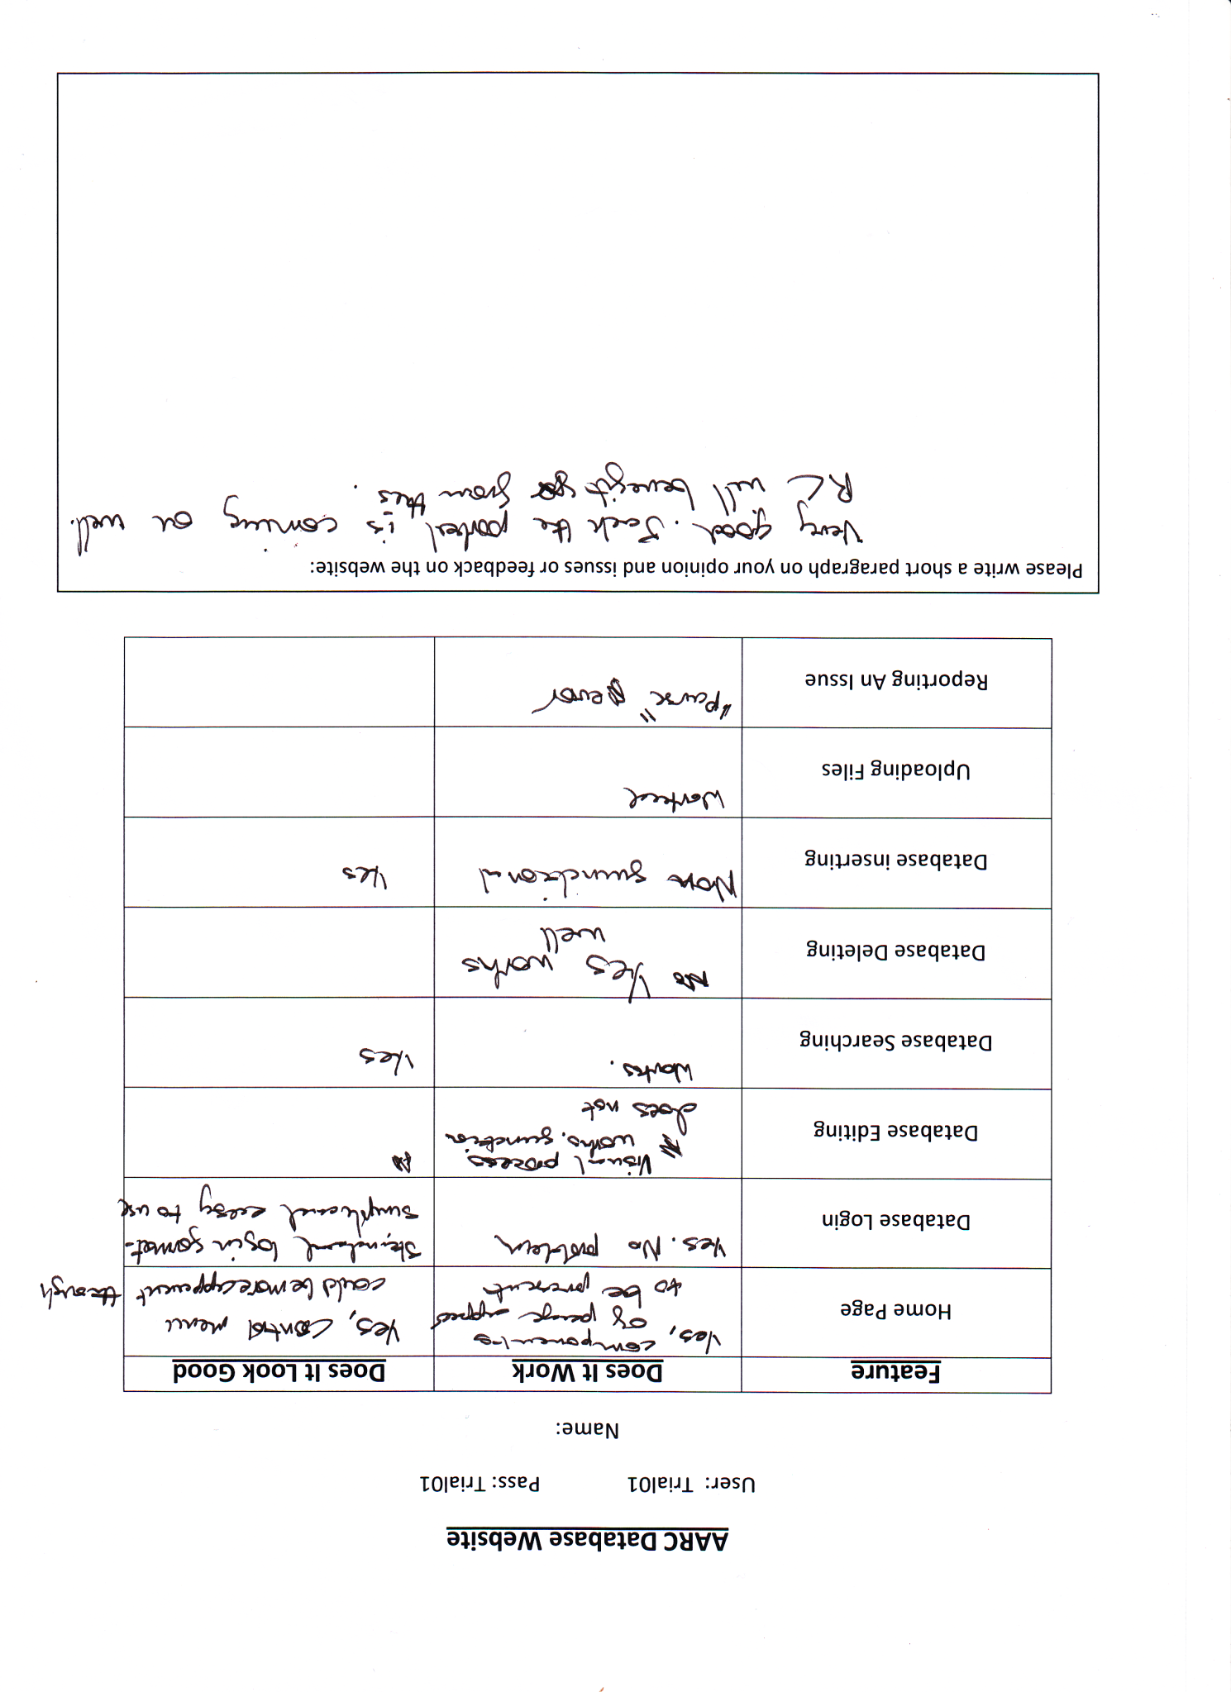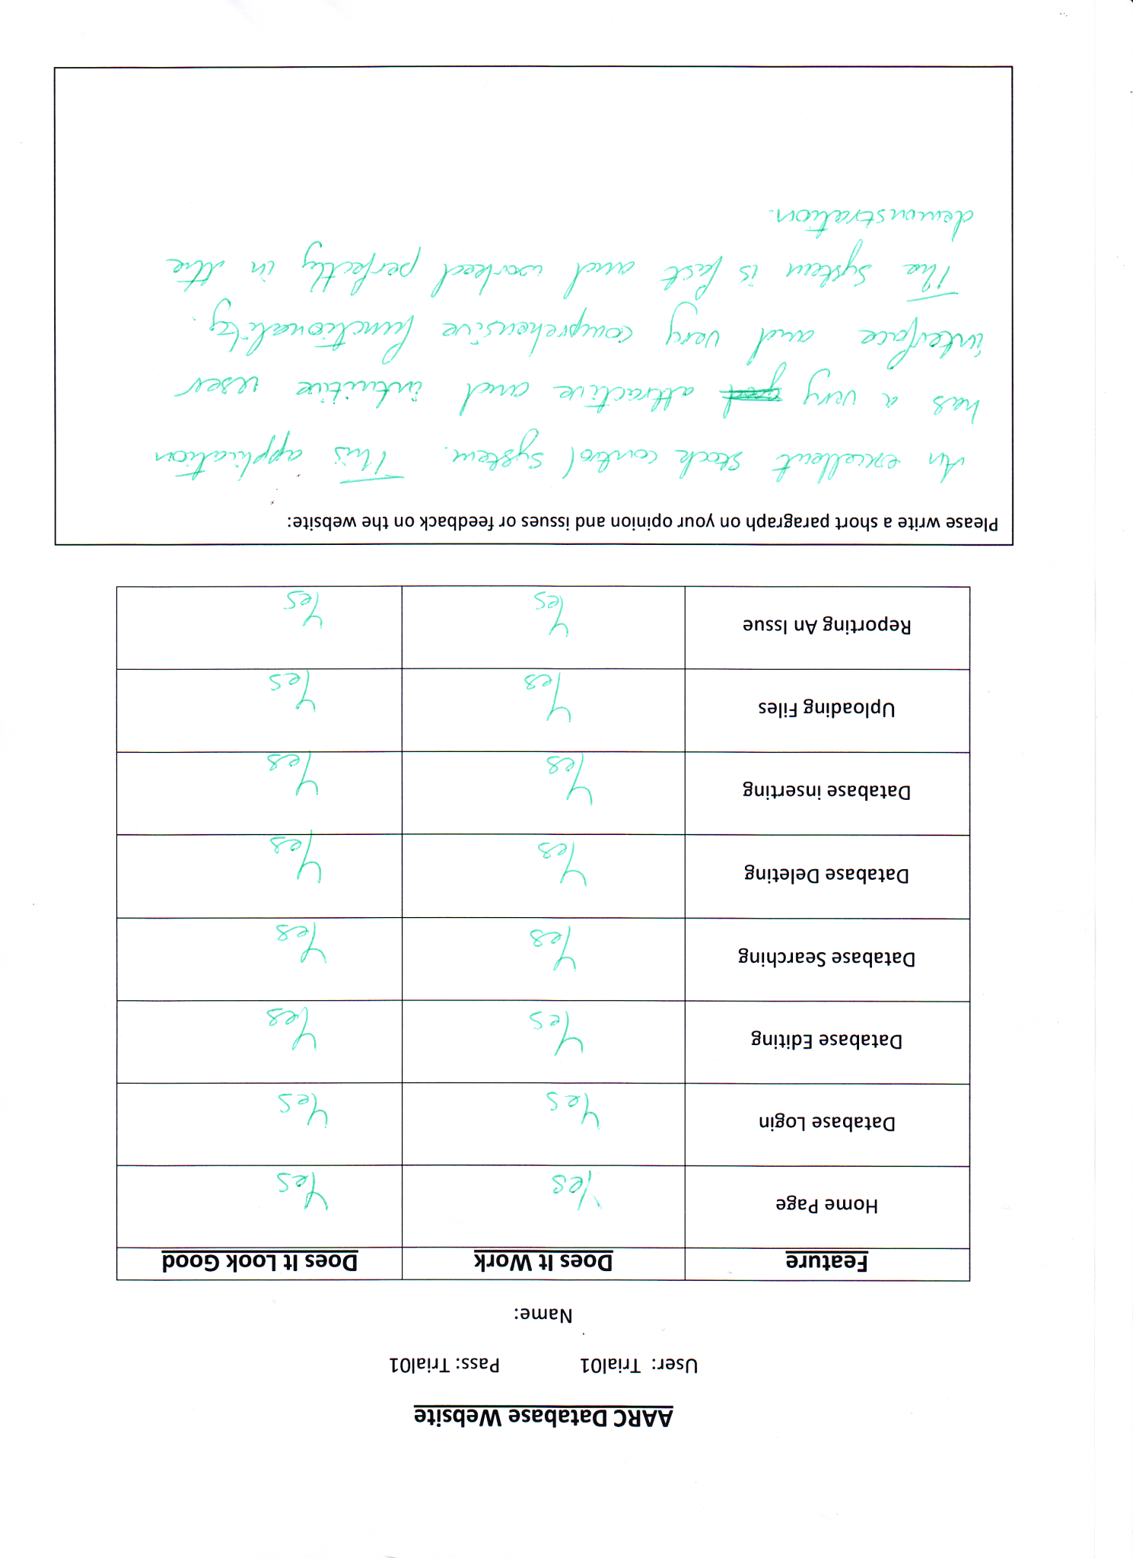

Felix

## Amends

* CCS of New Stock Link has been added so it’s now visible to users
* Back Link on delete page has been fixed so it points to the right page
* Help button removed on all menu bars
* Skip button added into the form on the database page to make it clear that logging in can be skipped
* Amended the request page so that the title and report data from the form is posted as they were commented out
* Request page has a restructure of the file creation
* Insert Stock page has the data passed assigned so that it can be reposted as part of a form so that the data carries onto the next page.
* Amend Stock has the data passed assigned so that it can be reposted as part of a form so that the data carries onto the next page.
* Both amend and Insert pages had data retention issues solved by sending the data to the next page rather than calling themselves.
* Pull out menu hasn’t had an adjustment to the position of a box to show the menu is there
* Database page has had protection from ‘ -- SQL hacks put in place as the club is aware of such methods to avoid passwords.

Blue Text – User Flagged Issues

|  |  |  |
| --- | --- | --- |
| CSS for Link | Visual - Functional | Pass |
| Back Link | Mouse: Click | Pass |
| Help Link | Visual - Functional | Pass |
| Skip Button | Mouse: Click | Pass |
| Amend Page Post | Page: Refresh | Pass |
| Request File Read/write | PHP Process | Pass |
| Insert Stock Data Retention | PHP Process | Pass |
| Amend Data Retention | PHP Process | Pass |
| Pull out menu User Recommend change | Visual – non Functional | Pass |
| User Validation Protection | PHP Process | Pas |

# Final user Evaluation

Each Feature scored out of 5

|  |  |  |  |  |  |  |
| --- | --- | --- | --- | --- | --- | --- |
| **Feature to Score** | **Callum C** | **Calum S** | **Josh** | **Aaron** | **Dominic** | **A.Speirs** |
| Page Titles are clear | 5 | 4 | 5 | 4 | 4 | 5 |
| Forms’ are Clear | 4 | 5 | 5 | 5 | 5 | 5 |
| Database Login is easy | 5 | 5 | 4 | 5 | 5 | 5 |
| Database Search is easy | 4 | 4 | 3 | 3 | 3 | 5 |
| Results table looks good | 5 | 5 | 4 | 5 | 4 | 4 |
| Upload looks simple | 5 | 5 | 5 | 5 | 5 | 5 |
| File Upload is Easy | 5 | 5 | 5 | 4 | 5 | 5 |
| Request Page is Simple | 5 | 5 | 4 | 5 | 5 | 4 |
| The Text a good Size | 4 | 5 | 5 | 4 | 5 | 5 |
| Font Is Choice good | 4 | 4 | 5 | 5 | 5 | 5 |
| There is no Lack of Colours | 3 | 4 | 4 | 3 | 4 | 4 |
| There is plenty of Content | 4 | 4 | 3 | 3 | 3 | 5 |
| Menu Use is Easy | 5 | 5 | 5 | 5 | 5 | 5 |
| Menu Colour is Good | 5 | 5 | 5 | 5 | 5 | 4 |
| Menu is Clear | 5 | 5 | 5 | 5 | 5 | 5 |
| Links all Work | 5 | 5 | 5 | 5 | 5 | 5 |
| Page Size is Appropriate | 4 | 5 | 5 | 5 | 4 | 5 |
| Site Navigation is Easy | 5 | 5 | 5 | 4 | 4 | 5 |
| The Website Self Explanatory | 4 | 5 | 4 | 5 | 5 | 4 |
| Your Overall Website Score | 5 | 5 | 4 | 5 | 5 | 5 |
| Total: (Out of 100) | 91 | 95 | 90 | 90 | 91 | 95 |

## Summary

With an mean Average overall score of 92/ 100 it’s safe to assume that the final users of the system are satisfied that the system will be able to be used to its specified functionality and that the visual appearance of the website is also satisfactory so that a majority of users will be able to self-navigate and be able to interpret the features the site provides.

The lower scoring features are the content of the website, the colours used through the site and performing a search on the database and this has been reported to be due to ether a lack of that particular feature or the process in reaching the database search is harder/confusing. Future adjustments would change these so that the site has more colours as well as more information or content. There could also be adjustments to the layout of the search form so that it’s more aligned and neat as these feature adjustments this will raise the score in future evaluations.

# Evaluation and Development Path

The evaluation will be split into two sections;

* Evaluation of the Project.
* Evaluation of the Development Process.

## Evaluation of the Project Solution

The project definitely meets the User Criteria Allowing access to an inventory of kit or files through a simple user interface and allows for users from across the club access to the service.

Provided the network page hasn’t been completed due to time constraints, future work may be carried out to finish this. However, the user survey did also flag that there were several members with the technical knowledge to be able to maintain the network and teach other members its ins and outs.

The purpose built reporting feature uses file handling and due to the nature of its implementation will never fail even if the size of the report is massive.

The Amend, Delete and Insert-Stock pages do have issues with data retention with ether going back pages or resubmitting data to the same page. This issue doesn’t affect the functionality of the page but only the efficiency at which it can be operated.

Alternative methods and procedures were used for many for the file and database operations carried out within the PHP due to several methods returning errors as they were not recognised, returning invalid or corrupt data types/values.

The Reporting an issue page had consistent file handling issues and one of the main reasons was a restriction in place by the php.inf file that prevented files from being closed for some reason. The issue it cause was the fact that apache itself would lock the file but because PHP tried to close a file it had opened and couldn’t, a parse error occurred as it thought that the file had met an unexpected end.

Another large limiting factor was the amount of available memory to the whole system and a technician dropped off spare memory modules so that the machines could be upgraded. This meant more memory could be allocated to xampp and therefore it could handle requests from more than 1 computer at a time unlike before.

Last of all, file uploads were hugely limited by not only a line of code preventing files over 2KB being uploaded but by php.inf file limiting the whole system file handling to only 2MB and this regularly threw errors when being passed files remotely close to that size.

A quick php manual reference online was able to help solve a lot of the limiting factors the php.inf file had imposed on the project.

However, it’s still unknown why certain methods and commands didn’t work during execution. There was no available info on whether a class library was missing or an older version of php prevented them from being used. Rather than using functions like ‘exec’ or row()->fetch_asscoc(), basic MySQL php commands had to be used like MySQL->query() and these commands came with plenty of horrible return values which took several hours sometimes to decipher as to what was being returned and their data types.

## Evaluation of the Development Process

The development schedule ran 4 days over the scheduled completion date as the Implementation stage had a couple extra days work but that other 2 days was the evaluation of the system rather than its testing phase completion. In a legal Situation, being overtime by 4 days could have left a company liable to be sued as the contract has been breached. Overtime in this case hasn’t left anyone liable however its cost more of my time and in a work place that costs a company more money.

With more time, more of the project could have been completed but since a reliable method of implementing and testing was used (Scrum methodology), much more was able to be completed as constant refinement of the solution and criteria to which I was working to was being made.

The process of collecting user test data and evaluations was a challenge as the details I required needed to be clearly set out. This was so I was given a level of detail which would allow me to be able to properly evaluate the system at each stage.

The user age is young which made developing and creating a process for the members to report and learn about the system was crucial as there aren’t currently enough technical skills to be able to fully understand the processes of the system provided they were too complex.

### Release Notes:

When using the back button after Amending and Deleting records from the database will result in the request for user details again as there is no data retention in that system.

The upload page will still update the database but not upload the file if an identical file is uploaded but this can be sorted in the data controls by an admin by checking for records with the same file location.

Network page is a blank template as that part of the project was postponed due to time constraints but still available to members to investigate and update themselves.

The Help Feature was removed as time doesn’t permit this feature to be implemented.

# References

* PHP & MYSQL Novice To Ninja By Kevin Yank ISBN 9780987153081
* Bulletproof Web Design By Dan Cederholm ISBN 9780321509024
* Database Design For Mere Mortals By Michael Hernandez ISBN 0201694719
* Relational Database Design By Jan Harrington ISBN 01558608206
* W3schools @ <http://www.w3schools.com>
* PHP Manual @ <http://php.net>